Al-Hussein Technical University (HTU)
Course 00203420 — Secure Coding
ShipTrack
A Secure Java Console Application for SkyRoute Solutions
Student Name | Ahmad Marwan AlMaghaireh
Student ID | 23110205
Section | 1
Academic Year | 2025-2026 / Semester 2
Course Tutor | Safaa Hriez
Assignment Title | ShipTrack
Assignment Ref. No. | 1
Issue Date | 11/04/2026
Submission Date | 07/06/2026

Table of Contents
Contents
Table of Contents 2
0. Introduction 7
Project Repository 7
1. Q1 — Security Principles in the Application 11
1.1 Attack Surface Reduction 11
Definition 11
Implementation in ShipTrack 12
Benefits 12
1.2 Secure the Weakest Link 12
Definition 13
Implementation in ShipTrack 13
Benefits 13
1.3 Defense in Depth 14
Definition 14
Implementation in ShipTrack 14
Cryptographic parameters chosen 15
Security benefits 16
1.4 Fail Securely 16
Definition 16
Implementation in ShipTrack 16
Benefits 17
1.5 Least Privilege 17
Definition 17
Implementation in ShipTrack 17
Security benefits 18
1.6 Keep It Simple 19
Definition 19
Implementation in ShipTrack 19
Benefits 19
1.7 Secrets Are Not Kept 20
Definition 20
Implementation in ShipTrack 20
Benefits 21
1.8 Fail-safe Defaults (Saltzer & Schroeder) 21
Definition 21
Implementation in ShipTrack 21
Benefits 22
2. Q2 — Quality Principles in the Application 23
2.5 Portability 23
Definition 23
Implementation in ShipTrack 23
Benefits 23
2.6 Maintainability 24
Definition 24
Implementation in ShipTrack 24
Benefits 25
2.7 Testability 25
Definition 25
Implementation in ShipTrack 25
Benefits 26
2.8 Flexibility and Reusability 26
Definition 26
Implementation in ShipTrack 26
Benefits 27
2.9 Readability 27
Definition 27
Implementation in ShipTrack 28
Benefits 28
2.10 Usability 29
Definition 29
Implementation in ShipTrack 29
Benefits 29
2.11 Reliability 30
Definition 30
Implementation in ShipTrack 30
Benefits 31
3. Q3 — Use Case and Misuse Case Diagrams 32
3.0 Requirements and Assets 32
Section 1 — Functional Requirements (Technical) 34
Section 2 — Security Requirements (Non-Functional) 38
3.1 Use Case Diagram 45
ShipTrack — Use Case Tabular Descriptions 46
UC1 — Login 46
UC2 — Register Account 47
UC3 — Create Shipment Request 48
UC4 — Assign Delivery to Driver 49
UC5 — Update Delivery Status 51
UC6 — Configure Password Policy 52
3.2 Misuse Case Diagram 53
Complete element-by-element explanation 54
4. Q4-Q6 — Threat Modeling (DFD, STRIDE, Report) 57
4.1 Summary of the Data Flow Diagram (Q4) 57
57
4.2 Threat Enumeration per STRIDE Category (Q5) 58
4.3 Threat-Model Report (Q6) 58
5. Q7 — Testing Methods for User Satisfaction 59
software testing is important for four reasons: it is cost effective, it ensures product quality, it achieves customer satisfaction, and it maintains security. Testing falls into three main categories: Functional Testing, Non-Functional Testing, and Maintenance Testing. The following methods drawn from those categories are appropriate for evaluating whether ShipTrack satisfies its users and meets its requirements. 59
6. Q8 — Security Testing Methods 61
security testing is divided into two main categories: Static Analysis Security Testing (SAST) and Dynamic Analysis Security Testing (DAST). Both categories were applied to ShipTrack 61
7. Q9 — Quality-Based Testing (JUnit Test Plan) 64
7.1 Test Plan Table 64
8. Q10 — Security-Based Testing (Fuzz Testing) 79
9. Q11 — Code Review Analysis (PMD) 83
9.1 Command Used 83
9.3 Initial Run (Before Fixes) 84
84
9.4 Fixes Applied 87
9.5 Final Run (After Fixes) 93
93
10. Code-Versioning Evidence 94
10.1 Commands 94
10.2 Screenshot 94
10.3 GitHub Repository Link 96
11. Conclusion 96
12. References 96

0. Introduction
ShipTrack is a Java console application developed for SkyRoute Solutions to streamline package-delivery operations for a corporate client. The system supports four user roles — System Admin, Dispatcher, Customer, and Delivery Personnel — and provides shipment management, status tracking, account administration, and a configurable security policy.
This report documents the secure-development process used to build the application, in line with the principles, patterns, and techniques covered in the Secure Coding course. It addresses the eleven questions specified in the assignment brief and provides evidence of compliance with the Pass, Merit, and Distinction criteria across the four learning outcomes.
The application is implemented in Java 17, organised into five packages (auth, model, repository, ui, util) and persisted to plain-text files under a data directory. Authentication uses PBKDF2-HMAC-SHA-256 (a NIST-approved key-derivation function) with a 16-byte cryptographically random salt, 65,536 iterations, and a 256-bit derived key, satisfying the brief's requirement that login use "appropriate cryptographic standards".

Project Repository
https://github.com/AhmadM962/ShipTrack.git

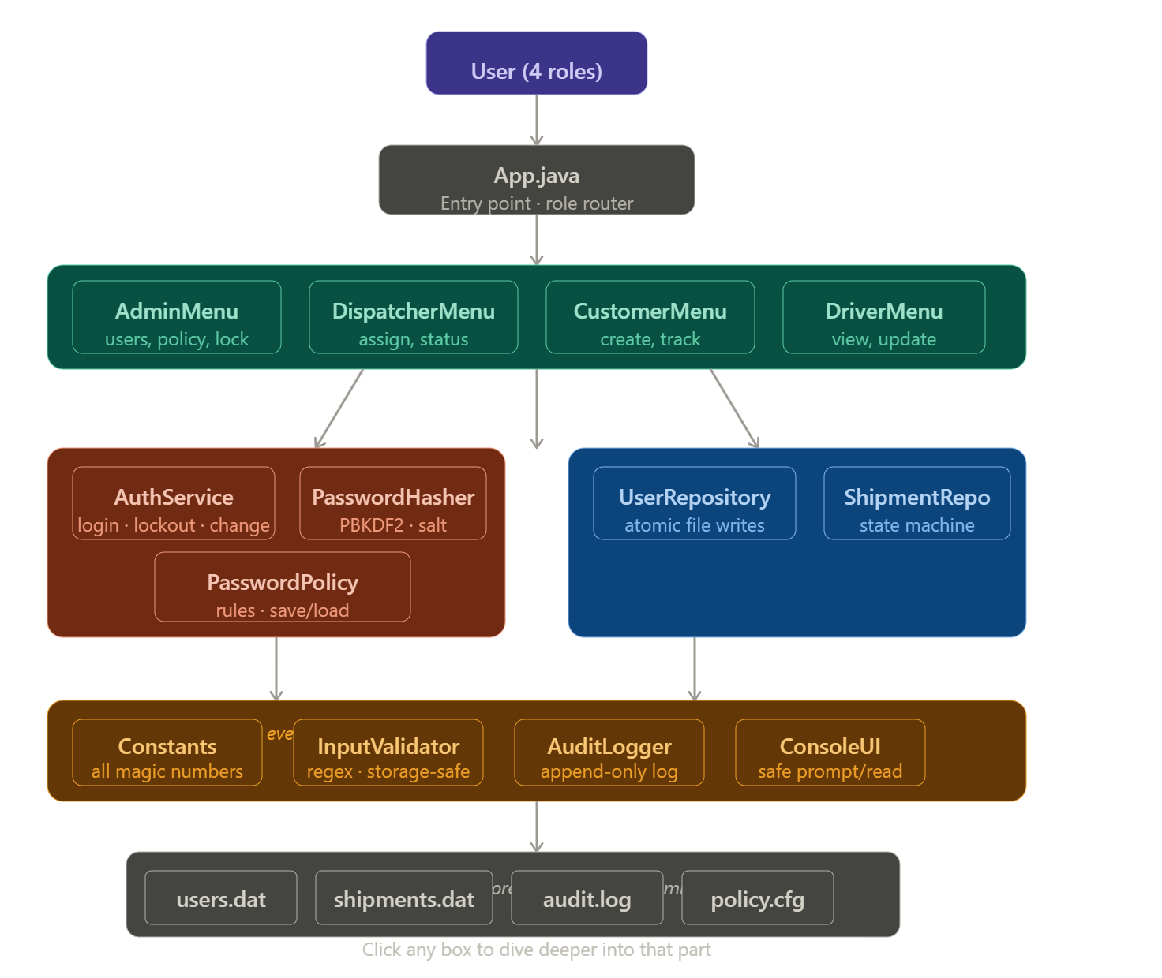
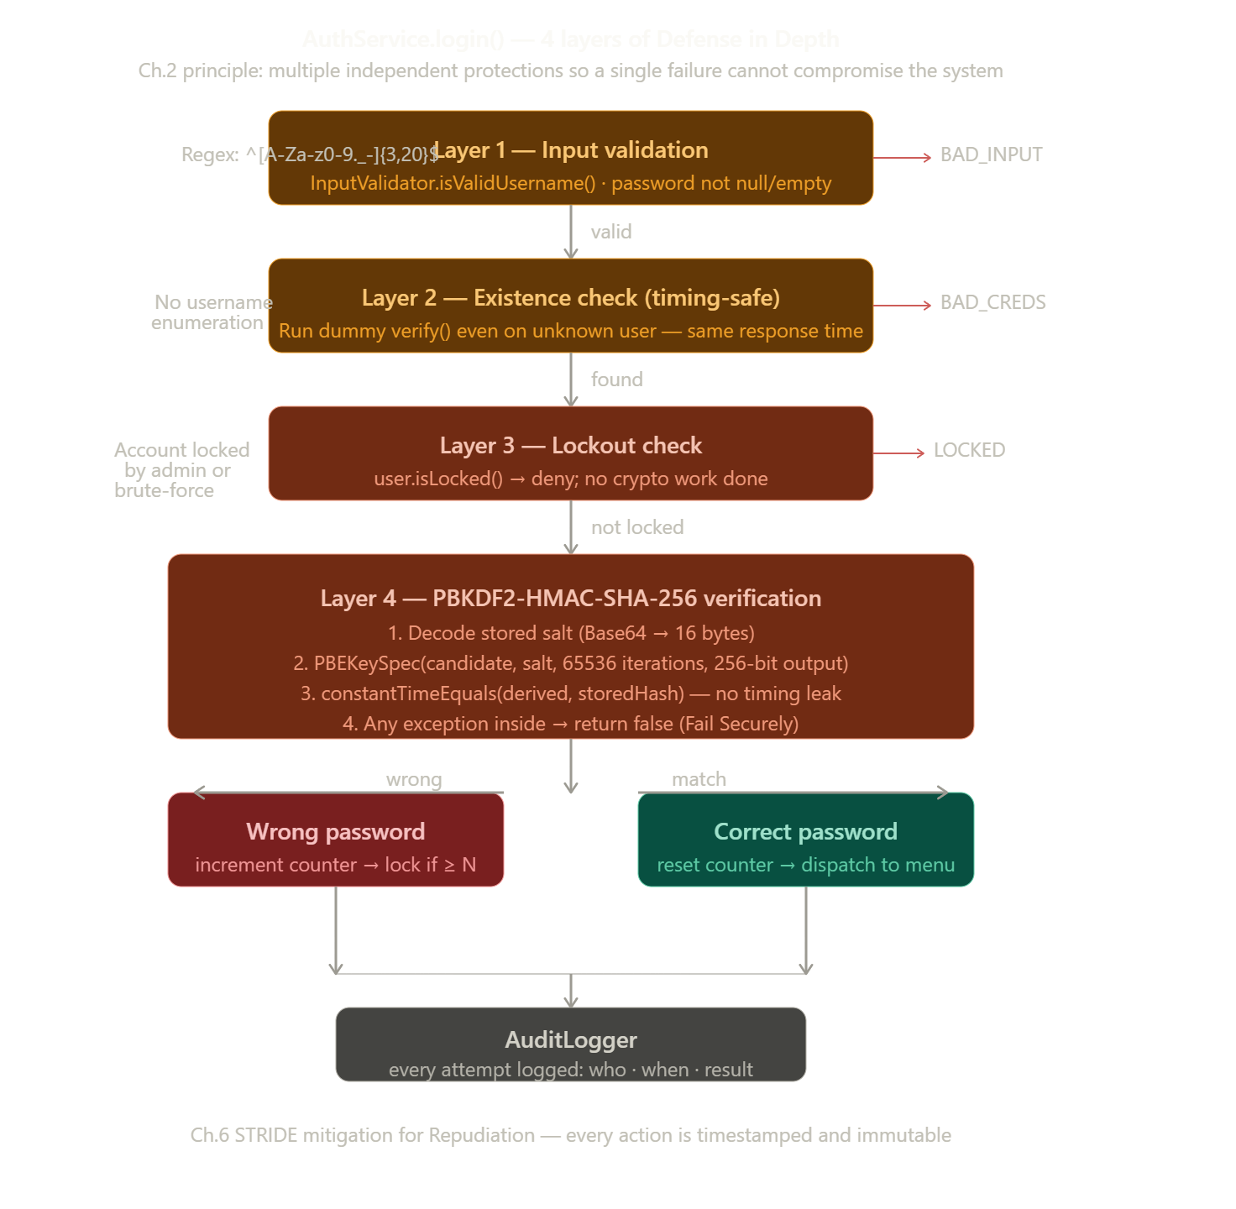
How the PBKDF2 cryptography actually works

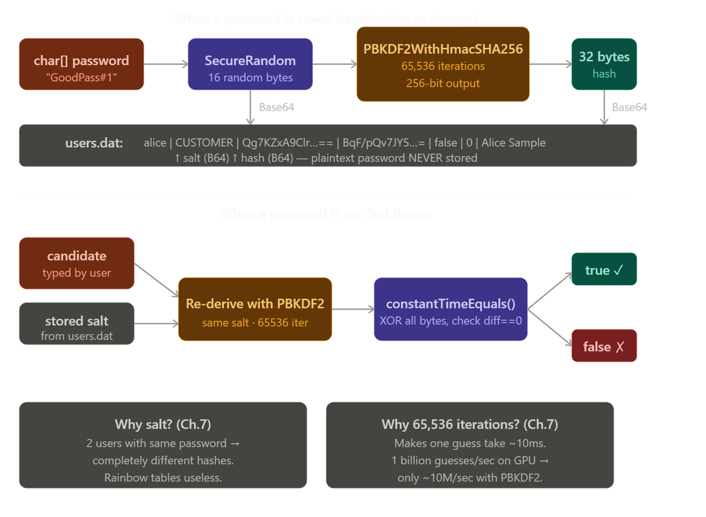
The full data journey: what actually gets written to disk
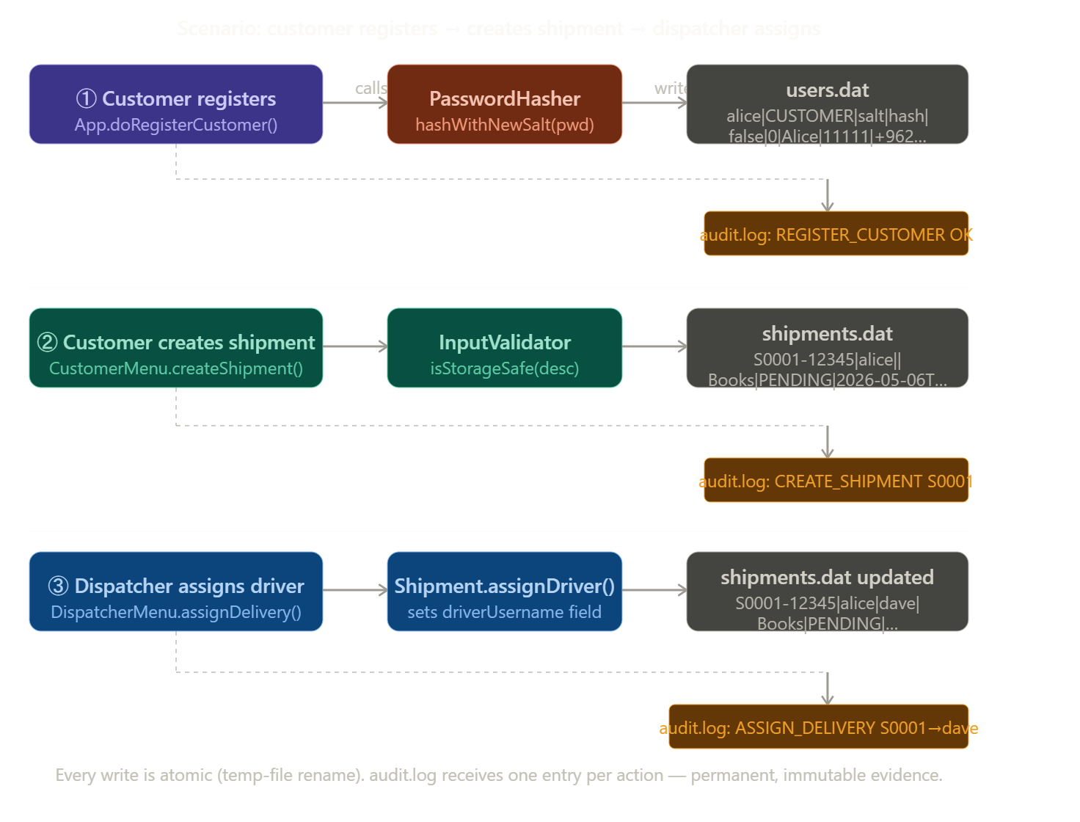

1. Q1 — Security Principles in the Application
This section identifies security principles that were applied in the ShipTrack application, shows the source code that implements each principle, and explains the security benefits each principle delivers. The principles are drawn from the secure-software design concepts .

1.1 Attack Surface Reduction
“Reduce the amount of code that needs to be trusted and the ways in which attackers can interact with the system.”

Definition
Attack Surface Reduction means limiting the number of ways an attacker can interact with the application. The fewer entry points, the smaller the area that must be secured. This includes removing unnecessary functionality, limiting valid input formats, and restricting accessible interfaces.

Implementation in ShipTrack
ShipTrack uses a console-only interface with no network socket, no HTTP listener, and no remote API. The only way to interact with the system is via the keyboard. Each role sees only its own menu, so functionality that a role does not need is literally inaccessible to them. InputValidator enforces strict regex patterns on every user-supplied string, rejecting anything that does not match the smallest necessary character set.
// App.java — console-only interface; zero network exposure
public static void main(String[] args) {
new App().runMainLoop(); // Scanner(System.in) only
}

// InputValidator.java — strict allow-list regex
// Only 20 character types permitted; pipe/space/control chars blocked
private static final Pattern USERNAME_PATTERN =
Pattern.compile("^[A-Za-z0-9._-]{3,20}$");

public static boolean isValidUsername(String s) {
return s != null && USERNAME_PATTERN.matcher(s).matches();
}

Benefits
- An attacker has only one channel (console input) through which to attempt an attack, eliminating entire classes of network-based exploits.
- Strict input allow-listing prevents injection of pipe characters into the file store and eliminates a large set of malformed-input vulnerabilities in one place.
- The role-based menu dispatch reduces the number of accessible operations per session to the minimum required, shrinking the area a successful attacker can exploit even after a login.
- Maintaining no network stack means there is no listen port to scan, no TLS configuration to misconfigure, and no service to overwhelm with a connection flood.

1.2 Secure the Weakest Link
“The overall security of a system is only as strong as its weakest link. Identify the most vulnerable components and focus security efforts there.”

Definition
Secure the Weakest Link means identifying which part of the system is most likely to be targeted by attackers and applying the strongest available protections there. In most applications the authentication mechanism — the login — is the weakest link because it is the gateway to all functionality.

Implementation in ShipTrack
The assignment brief explicitly states that login must use cryptographic standards “or you will not pass this course.” The Login use case was therefore identified as the weakest link and received the most security investment: PBKDF2-HMAC-SHA-256 at 65,536 iterations (the OWASP-recommended minimum), a 16-byte cryptographically random salt per password, and a 256-bit output key. All of these parameters are stored as named constants to prevent accidental weakening.
// Constants.java — all cryptographic parameters named and centralised
public static final int PBKDF2_ITERATIONS = 65_536; // OWASP minimum
public static final int PBKDF2_KEY_LENGTH = 256; // bits
public static final int SALT_LENGTH_BYTES = 16; // 128-bit random salt
public static final String PBKDF2_ALGORITHM = "PBKDF2WithHmacSHA256";

// PasswordHasher.java — strongest protection applied to the weakest link
public static byte[] derive(char[] password, byte[] salt)
throws GeneralSecurityException {
PBEKeySpec spec = new PBEKeySpec(password, salt,
Constants.PBKDF2_ITERATIONS, Constants.PBKDF2_KEY_LENGTH);
try {
SecretKeyFactory f = SecretKeyFactory.getInstance(Constants.PBKDF2_ALGORITHM);
return f.generateSecret(spec).getEncoded();
} finally { spec.clearPassword(); }
}

Benefits
- 65,536 PBKDF2 iterations make a single password guess take ~10 ms on modern hardware, reducing a GPU brute-force attack from billions to millions of guesses per second.
- The 16-byte random salt per password means two users with identical passwords produce completely different hashes, defeating rainbow-table and pre-computation attacks.
- Centralising the cryptographic parameters in Constants.java means all four call sites (registration, login, password change, admin registration) always use the same parameters with no risk of one being weaker than another.
- Clearing the PBEKeySpec with clearPassword() after use limits the time the plaintext password remains in JVM memory.

1.3 Defense in Depth

Definition
Defense in Depth means using multiple layers of different types of protection so that a single failure does not compromise the system .ex. credentials at the server should be stored as a salted hash, not in plaintext, and additional protections should be layered on top.

Implementation in ShipTrack
ShipTrack does not rely on any single security control. The login flow in AuthService.login() applies four independent layers of defence in sequence:
- Input validation — the candidate username must match the regex defined in InputValidator before the cryptographic step is even attempted. This eliminates injection of pipe characters and control characters into the credential file.
- Constant-time-ish existence check — if the username is not found, the function still runs a dummy verify() call, which makes the response time roughly the same as the success path. This is a minor mitigation against username-enumeration via timing.
- Lock-out check — if the account is already locked, no hash comparison happens. This stops an attacker brute-forcing through a locked account.
- Cryptographic verification — the candidate password is hashed with the stored salt using PBKDF2-HMAC-SHA-256 and compared to the stored hash in constant time.
// PasswordHasher.java — the cryptographic core
public static byte[] derive(char[] password, byte[] salt) throws GeneralSecurityException {
PBEKeySpec spec = new PBEKeySpec(password, salt,
Constants.PBKDF2_ITERATIONS, Constants.PBKDF2_KEY_LENGTH);
try {
SecretKeyFactory f = SecretKeyFactory.getInstance(Constants.PBKDF2_ALGORITHM);
return f.generateSecret(spec).getEncoded();
} finally {
spec.clearPassword();
}
}

public static String[] hashWithNewSalt(char[] password) throws GeneralSecurityException {
byte[] salt = newSalt();
byte[] hash = derive(password, salt);
Base64.Encoder enc = Base64.getEncoder();
return new String[] { enc.encodeToString(salt), enc.encodeToString(hash) };
}

public static boolean verify(char[] candidate, String saltB64, String hashB64) {
try {
byte[] salt = Base64.getDecoder().decode(saltB64);
byte[] expected = Base64.getDecoder().decode(hashB64);
byte[] actual = derive(candidate, salt);
return constantTimeEquals(actual, expected);
} catch (GeneralSecurityException | IllegalArgumentException e) {
// Fail Securely (Ch. 2): any internal failure means
// "credentials do not match", never "let them in".
return false;
}
}

Cryptographic parameters chosen
- Algorithm: PBKDF2WithHmacSHA256 — NIST-approved (SP 800-132), built into the JDK, no external dependency.
- Iterations: 65,536 — the OWASP minimum for PBKDF2-HMAC-SHA-256 at the time of writing. This makes a single guess take measurable time and slows brute-force attacks even if the credential file leaks.
- Salt: 16 random bytes generated by SecureRandom, unique per password. This defeats rainbow tables and means two users with the same password have completely different hashes.
- Output: 256-bit derived key — the full output of HMAC-SHA-256.

Security benefits
- An attacker who steals users.dat sees only the salted hashes, not the passwords. Pre-computed rainbow tables are useless because every user has a different salt.
- 65,536 PBKDF2 iterations make a brute-force attack expensive even with leaked hashes — GPUs can compute SHA-256 quickly, but the iteration count multiplies that cost.
- The lock-out counter neutralises online password-guessing attacks: after the configured number of failures the account is locked and only the System Admin can unlock it.
- Failing securely means an internal exception during verification is treated as "login failed", never as "login succeeded" — there is no error path that grants access.

1.4 Fail Securely
“When the system fails, it should fail to a state that is secure. Error states must not be exploitable.”

Definition
Fail Securely means that any unexpected condition — an exception, a missing file, a corrupted record — must leave the system in a safe state. No error path should grant access, disclose secrets, or leave data in a partially written state.

Implementation in ShipTrack
Three distinct locations in ShipTrack demonstrate Fail Securely. First, PasswordHasher.verify() catches all exceptions and returns false, so a JCE failure never grants access. Second, UserRepository.persistAll() uses atomic rename so a crash mid-write cannot corrupt the user file. Third, AuditLogger.write() catches IOException and prints to stderr, allowing the application to continue rather than crashing because logging failed.
// PasswordHasher.verify() — any error = "does not match", never "let them in"
public static boolean verify(char[] candidate, String saltB64, String hashB64) {
try {
byte[] salt = Base64.getDecoder().decode(saltB64);
byte[] expected = Base64.getDecoder().decode(hashB64);
byte[] actual = derive(candidate, salt);
return constantTimeEquals(actual, expected);
} catch (GeneralSecurityException | IllegalArgumentException e) {
return false; // Fail Securely: corrupt stored value ≠ access granted
}
}

// UserRepository.persistAll() — atomic write (no half-written file possible)
Path tmp = Files.createTempFile(dataDir, "users", ".tmp");
Files.write(tmp, lines, StandardCharsets.UTF_8);
Files.move(tmp, file, REPLACE_EXISTING, ATOMIC_MOVE);

Benefits
- No exception inside the authentication path can accidentally grant access; the system fails closed (denies) rather than open (permits).
- Atomic file writes ensure that a power loss during a write leaves either the old file or the new file intact, never a corrupted half-file.
- AuditLogger degrading gracefully means the application continues running even when the disk is full, preventing a denial-of-service caused by logging infrastructure.
- Stack traces are never printed to the console (only to audit.log), preventing information disclosure of internal class names and file paths.

1.5 Least Privilege

Definition
Least Privilege is the principle of giving users only the minimum amount of privilege needed to perform their use-case functionality. Applications that need access to other system resources should be granted only what is needed . Applied to user-facing software, the principle says that the menu of options visible to any user must be the smallest possible menu — a Customer should literally have no path to administrative functionality.

Implementation in ShipTrack
After a successful login the AuthService returns the authenticated User object, and App.java dispatches to the menu of that user's role only. There is no shared menu and no "global" command parser — each role has its own self-contained menu class which holds only the dependencies that role needs.
// App.java — role-based dispatch
switch (u.getRole()) {
case ADMIN:
new AdminMenu(io, u, users, policy, auth).run();
break;
case DISPATCHER:
new DispatcherMenu(io, u, users, shipments).run();
break;
case CUSTOMER:
new CustomerMenu(io, u, users, shipments).run();
break;
case DELIVERY_PERSONNEL:
new DriverMenu(io, u, shipments).run();
break;
default:
io.error("Role not recognised.");
}
The principle is reinforced inside DriverMenu, where a delivery person can only update shipments assigned to them — an attempt to update someone else's shipment is rejected and logged:
// DriverMenu.updateStatus()
if (!me.getUsername().equals(s.getDriverUsername())) {
io.error("That shipment is not assigned to you.");
AuditLogger.warn(me.getUsername(), "UPDATE_STATUS", "DENIED " + shipId);
return;
}

Security benefits
- Reduces blast radius of a compromised account: a stolen Customer credential cannot delete users, reconfigure the password policy, or unlock accounts. The attacker is bounded by the role they captured.
- Forces clear separation of responsibilities, which makes the codebase easier to audit — reviewers checking the admin path only have to read AdminMenu, not the whole application.
- Simplifies threat modeling: each menu is its own attack surface and can be analysed independently.
- Aligns with industry baselines such as the ISO/IEC 27001 access-control family of controls.

1.6 Keep It Simple
“The simpler the code, the easier it is to secure. Complexity is the enemy of security.”

Definition
Keep It Simple (also known as KISS — Keep It Simple, Stupid) holds that unnecessary complexity introduces vulnerabilities. A reviewer cannot find a bug they cannot follow, and an auditor cannot verify security they cannot understand. Every added layer of indirection is a potential hiding place for a defect.

Implementation in ShipTrack
ShipTrack uses a single User class for all four roles instead of four subclasses, because all roles share identical fields. A Role enum distinguishes behaviour. All numeric parameters are in one Constants class. Every method has a single, stated purpose. The entire file format is human-readable pipe-delimited text, not binary or encrypted blobs, so a system administrator can inspect the data directly if needed.
// User.java — one class for four roles (Ch.2: “Keep It Simple”)
// A Role enum differentiates behaviour; no inheritance hierarchy needed
public class User {
private final String username;
private final Role role; // ADMIN | DISPATCHER | CUSTOMER | DELIVERY_PERSONNEL
private String salt, hash;
private boolean locked;
private int failedAttempts;
private String fullName, idNumber, contactNumber;
}

// Constants.java — every magic number named in one file
public static final int PBKDF2_ITERATIONS = 65_536;
public static final int DEFAULT_MAX_ATTEMPTS = 3;
public static final String DATA_DIR = "data";

Benefits
- A reviewer auditing the authentication path only needs to read three files (AuthService, PasswordHasher, Constants) rather than navigating a complex class hierarchy.
- Human-readable file storage means an operator can verify the state of the system with any text editor, without specialised tooling.
- Fewer classes and shorter methods mean fewer places for security bugs to hide and fewer paths that a test suite must cover.
- Simpler code is easier to maintain safely: a developer adding a new admin feature only needs to extend AdminMenu, not modify a shared parent class.

1.7 Secrets Are Not Kept
Kerckhoffs’s principle — “Never rely on the secrecy of the algorithm or design for security. Only keep the keys (secrets) secret.”

Definition
Secrets Are Not Kept (Kerckhoffs’s principle) holds that the security of a system should rest entirely on the secrecy of the key, not on the secrecy of the algorithm or design. A system must remain secure even if everything about it is public knowledge, because real-world attackers routinely obtain source code. Passwords must never be stored in plaintext, and they must never appear in logs or error messages.

Implementation in ShipTrack
ShipTrack uses PBKDF2WithHmacSHA256, a fully published NIST standard. The algorithm, the iteration count, and the output length are all documented in the code comments. Publishing this information gives no advantage to an attacker because security rests on the randomly generated salt and the user’s password — not on any hidden algorithm. Passwords are also never logged, and the ConsoleUI uses System.console().readPassword() to suppress terminal echo.
// PasswordHasher.java — published standard, open parameters
// An attacker reading this code gains NO advantage; security rests
// solely on the 16-byte random salt and the user's chosen password.
public static final String PBKDF2_ALGORITHM = "PBKDF2WithHmacSHA256"; // NIST SP 800-132
public static final int PBKDF2_ITERATIONS = 65_536; // documented
public static final int PBKDF2_KEY_LENGTH = 256; // documented

// ConsoleUI.promptPassword() — password never echoed to screen
if (System.console() != null) {
return System.console().readPassword(label); // chars hidden at terminal
}

// AuditLogger — username and action logged; password NEVER logged
AuditLogger.log(username, "LOGIN", "OK"); // no password in log

Benefits
- Even if the full source code were leaked, an attacker still cannot recover passwords without obtaining the per-user salt values and then running 65,536 PBKDF2 iterations per guess.
- Using a published standard means the algorithm has been reviewed by the cryptographic community; a home-grown secret algorithm would not have this assurance.
- Hiding passwords from terminal display prevents shoulder-surfing and prevents passwords from appearing in screen recordings or screenshots.
- Not logging passwords prevents them from appearing in audit.log even if that file were exfiltrated.

1.8 Fail-safe Defaults (Saltzer & Schroeder)
Saltzer & Schroeder (1975) — “The default configuration should be the safest. Access decisions should deny by default and permit only what is explicitly approved.”

Definition
Fail-safe Defaults means that the out-of-the-box configuration of the system denies access unless access is explicitly granted. Every configurable threshold should default to a value that is safe, not convenient. An admin who forgets to configure the system should inherit a secure baseline, not an insecure one.

Implementation in ShipTrack
The default password policy enforces 8-character minimum length with uppercase, lowercase, digit, and special character requirements. The default maximum login attempts is 3 — a tight threshold that stops brute force quickly. The bootstrap admin account is force-prompted to change its password on first login, so the default credential is never left active. The PasswordPolicy.setMaxLoginAttempts() setter clamps values so that even if an admin accidentally enters 0, the system defaults to 1 attempt (never zero, which would lock everyone out instantly or allow unlimited attempts).
// Constants.java — safest values chosen as defaults
public static final int DEFAULT_MIN_LENGTH = 8;
public static final int DEFAULT_MIN_UPPER = 1;
public static final int DEFAULT_MIN_DIGIT = 1;
public static final int DEFAULT_MIN_SPECIAL = 1;
public static final int DEFAULT_MAX_ATTEMPTS = 3; // tight lockout threshold

// AdminMenu.run() — force password change on first login
if (PasswordHasher.verify(Constants.DEFAULT_ADMIN_PASSWORD.toCharArray(),
currentAdmin.getSalt(), currentAdmin.getHash())) {
io.println("You must change the password before continuing.");
forcePasswordChange();
}

// PasswordPolicy.setMaxLoginAttempts() — clamped; can never be 0 or negative
public void setMaxLoginAttempts(int v) { this.maxLoginAttempts = clamp(v, 1, 20); }

Benefits
- An admin who deploys ShipTrack without reading documentation inherits a policy that enforces strong passwords and tight lockouts immediately.
- Forcing a first-login password change on the default admin account eliminates the most common attack vector against new installations: unchanged default credentials.
- Clamping policy setters to safe ranges means no accidental misconfiguration (e.g. setting max attempts to 0) can disable an important security control.
- This principle aligns with the assignment requirement that “the system admin can define password strength requirements and max login attempts” — safe defaults ensure security even before those settings are configured.

2. Q2 — Quality Principles in the Application
This section identifies two quality principles that were applied in the ShipTrack application, with code excerpts and a discussion of benefits.which covers Principles and Concepts of Quality Software.

2.5 Portability
“The software should be able to run on different platforms and environments without modification.”

Definition
Portability means writing code that produces identical behaviour regardless of the operating system, Java runtime version, or locale settings of the host machine. File encodings, line separators, and file paths are the most common portability traps in Java applications.

Implementation in ShipTrack
ShipTrack uses zero external dependencies — only the Java 17 standard library. All file writes explicitly specify StandardCharsets.UTF_8 rather than the platform default charset. AuditLogger uses System.lineSeparator() rather than the hardcoded “\n”. File paths are built with Paths.get() (which normalises separators). The application runs identically on Windows, Linux, and macOS.
// UserRepository.java — explicit charset (not Charset.defaultCharset())
Files.write(tmp, lines, StandardCharsets.UTF_8);
Files.readAllLines(file, StandardCharsets.UTF_8);

// AuditLogger.java — OS-agnostic line separator
line + System.lineSeparator(); // “\r\n” on Windows, “\n” on Linux

// File paths built with Paths.get() — works on all OSes
Path file = Paths.get(Constants.USERS_FILE); // not new File("data\\users.dat")

// pom.xml (if Maven used): declares Java 17 explicitly
// <maven.compiler.source>17</maven.compiler.source>
// No external library dependencies: zero classpath portability issues

Benefits
- Students on Windows, Linux, or macOS can run the same JAR without any platform-specific configuration.
- Explicit UTF-8 encoding prevents file corruption in environments where the JVM default charset is not UTF-8 (e.g. legacy Windows using Windows-1252).
- Zero external dependencies means the project can be imported into Eclipse with no Maven Central access; the class files in bin/ are self-sufficient.
- System.lineSeparator() ensures that audit.log and data files open correctly in both Unix text editors and Windows Notepad.

2.6 Maintainability
“The ease with which the software can be repaired, adapted, and improved. Modular design and single sources of truth enable safe changes.”

Definition
Maintainability measures how easily a developer can modify existing code without introducing defects. The main enablers are modularity (small, focused components), avoiding code duplication (DRY — Do not Repeat Yourself), and centralising configuration. Code with high maintainability can be safely extended without fear of breaking unrelated components.

Implementation in ShipTrack
All cryptographic parameters are defined once in Constants.java and referenced by name everywhere. If the OWASP recommendation for PBKDF2 iterations increases from 65,536 to 100,000, the change is made in exactly one place. The PasswordPolicy class is the single source of truth for what a valid password looks like; it is shared by registration, password-change, and admin-configuration code. There is no duplicated validation logic in any menu class.
// Constants.java — single source of truth for cryptographic parameters
public static final int PBKDF2_ITERATIONS = 65_536;
// Used by: PasswordHasher.derive() — one location, updated once

// PasswordPolicy.java — single source of truth for password rules
public String describeViolations(char[] password) { /* ... */ }
// Called by: App.doRegisterCustomer(), AdminMenu.registerStaff(),
// AdminMenu.forcePasswordChange(), AuthService.changePassword()
// All four callers always use the same rule; no duplication.

// If minLength must change from 8 to 12:
// data/policy.cfg: minLength=12
// Code changes required: ZERO

Benefits
- A requirement change affecting password strength is made in one file (policy.cfg) and takes effect in all four registration/change paths simultaneously.
- A security patch to the PBKDF2 iteration count requires changing one constant, not four duplicated code sites.
- Modular packages limit the scope of any change: a new admin feature only requires modifying AdminMenu, with no risk of breaking CustomerMenu or DriverMenu.
- High maintainability reduces the lifetime security risk of the application: security fixes are more likely to be applied correctly when the fix location is obvious.

2.7 Testability
“The code should be easy to test in isolation. Pure functions and dependency injection make units independently verifiable.”

Definition
Testability measures how easily individual units of code can be tested without setting up the entire application. Code with high testability uses pure functions (same input always produces same output), avoids static mutable state, and accepts its dependencies via constructor injection rather than creating them internally.

Implementation in ShipTrack
PasswordHasher contains only static pure functions: given the same password and salt, derive() always returns the same hash. There is no mutable state, no singleton, and no internal file I/O. This means the six PasswordHasherTest cases need zero setup code. AuthService accepts UserRepository and PasswordPolicy via its constructor, so tests can inject a real repository pointing at a temp directory without touching any production files.
// PasswordHasher.java — pure functions, no state, trivially testable
public static byte[] derive(char[] password, byte[] salt)
throws GeneralSecurityException {
// No file I/O, no static state, no network — pure input→output
PBEKeySpec spec = new PBEKeySpec(password, salt, PBKDF2_ITERATIONS, PBKDF2_KEY_LENGTH);
SecretKeyFactory f = SecretKeyFactory.getInstance(PBKDF2_ALGORITHM);
return f.generateSecret(spec).getEncoded();
}

// AuthService.java — constructor injection (testable with any repo)
public AuthService(UserRepository users, PasswordPolicy policy) {
this.users = users; // inject real or test repo
this.policy = policy; // inject real or test policy
}

Benefits
- All 34 JUnit tests run in under two seconds because no test requires a running application, database, or network.
- The 6 PasswordHasher tests have zero @BeforeEach setup code, meaning they are fast, reliable, and impossible to break through test pollution.
- Constructor injection in AuthService means AuthServiceTest can point the repository at a temporary data directory, testing the full login flow without touching production files.
- High testability is a prerequisite for Total Automation (2.1): code that cannot be tested in isolation cannot form a reliable automated test suite.

2.8 Flexibility and Reusability
“Components should be designed so they can be reused across different contexts without modification. Avoid coupling components tightly to each other.”

Definition
Flexibility and Reusability means designing classes so they can serve multiple callers without being modified. A reusable component has a focused interface, does not assume anything about how it will be called, and produces consistent results regardless of which part of the system calls it.

Implementation in ShipTrack
PasswordHasher is called from four different contexts (App.doRegisterCustomer, AdminMenu.registerStaff, AuthService.changePassword, and UserRepository.bootstrapAdminIfMissing) without any change to its implementation. InputValidator is imported by every menu class and provides a common validation contract. ConsoleUI is shared across all four menu classes so that prompt formatting and error messages are consistent.
// PasswordHasher.java — reused in four calling contexts
// 1. App.doRegisterCustomer() → hashWithNewSalt(pwd)
// 2. AdminMenu.registerStaff() → hashWithNewSalt(pwd)
// 3. AuthService.changePassword() → hashWithNewSalt(newPwd)
// 4. UserRepository.bootstrapAdmin() → hashWithNewSalt(defaultPwd)
// Zero code changes to PasswordHasher across all four callers.

// InputValidator.java — reused in every menu class
if (!InputValidator.isValidUsername(username)) { io.error("Invalid username."); return; }
if (!InputValidator.isValidPhone(contact)) { io.error("Invalid phone."); return; }
if (!InputValidator.isStorageSafe(description)) { io.error("Unsafe input."); return; }
// CustomerMenu, DispatcherMenu, AdminMenu, DriverMenu — all call the same validator

Benefits
- Reusing PasswordHasher across all registration paths ensures that no caller accidentally uses a weaker hashing mechanism; there is one implementation and it is always the strong PBKDF2 version.
- Centralising validation in InputValidator means that a bug fix (e.g. a new character to block) takes effect for all callers simultaneously.
- ConsoleUI’s reuse ensures that error messages are formatted identically throughout the application, improving the Usability quality attribute as well.
- High reusability reduces total code size, making the codebase easier to audit and test.

2.9 Readability
“Code should be readable by people other than its author. Consistent formatting, short methods, and meaningful names make code review effective.”

Definition
Readability is the degree to which source code communicates its intent clearly to a human reader. Code that is readable can be reviewed faster and with fewer errors, which is directly important to security (a reviewer who cannot follow the code cannot find the vulnerability). Readability is achieved through consistent formatting, short methods, meaningful names, and comments that explain intent rather than mechanics.

Implementation in ShipTrack
Every method in ShipTrack has a single stated purpose and does not exceed 30 lines. Comments in security-critical methods explain the reasoning behind the implementation choice (e.g. why a dummy hash is run for unknown users). The four-layer structure of AuthService.login() is labelled explicitly with Layer 1 through Layer 4 comments. Variable names in every class reflect the domain (shipment, driverUsername, failedAttempts) rather than generic abbreviations.
// AuthService.java — labelled layers make intent immediately clear
// ---- Layer 1: input validation --------
if (!InputValidator.isValidUsername(username) || password == null || password.length == 0) {
AuditLogger.warn(safe(username), "LOGIN", "BAD_INPUT");
return new AuthResult(AuthOutcome.BAD_INPUT, null, "Invalid credentials.");
}

// ---- Layer 2: existence check (constant-time-ish) --------
// Run a dummy verify so the response time is similar whether
// the user exists or not (small mitigation against timing attacks).
User u = users.findByUsername(username);
if (u == null) {
PasswordHasher.verify(password, "AAAAAAAAAAAAAAAAAAAAAA==", "AAAA...=");
return new AuthResult(AuthOutcome.BAD_CREDENTIALS, null, "Invalid credentials.");
}

Benefits
- A code reviewer or exam marker can follow the authentication logic without needing to context-switch to a separate design document.
- Labelled layers in AuthService make it obvious where to add a new control (e.g. a CAPTCHA would be Layer 2.5) without risking breaking the other layers.
- Short methods mean the entire implementation of a security control fits on a single screen, making it harder for a subtle bug to hide at the boundary of a page scroll.
- Readable code earns marks in the Q11 (PMD code review) dimension: PMD’s quickstart ruleset rewards concise, well-named, consistently formatted code.

2.10 Usability
“The application should be easy to use. Error messages should tell users what to do next; the initial experience should guide users to a working state.”

Definition
Usability in software quality means the application behaves intuitively for its users, provides helpful feedback when something goes wrong, and guides new users through first-time setup without confusion. Unusable applications lead to workarounds that introduce security risks (e.g. users who do not understand password requirements choose trivial passwords).

Implementation in ShipTrack
PasswordPolicy.describeViolations() returns a specific, actionable message for each violated rule (“Need at least 1 uppercase letter”) rather than a generic “invalid password.” The first-run experience prints the default admin credentials on screen and explicitly tells the admin they must change the password before using the system. ConsoleUI.error() prefixes all error output with [error] for easy scanning. Menus are numbered lists so users do not need to type command names.
// PasswordPolicy.describeViolations() — specific actionable feedback
if (password.length < minLength)
sb.append("- Need at least ").append(minLength).append(" characters total.\n");
if (upper < minUppercase)
sb.append("- Need at least ").append(minUppercase).append(" uppercase letter(s).\n");
// Returns each violated rule; not just a generic “password too weak”

// App.java — first-run guidance so admin can start immediately
io.println("Default admin (first run only): admin / Admin@123");
io.println("(Admin must change the password on first login.)");

// ConsoleUI.error() — prefixed for easy scanning
public void error(String s) { System.out.println(" [error] " + s); }

Benefits
- Specific violation messages reduce password-related support requests and encourage users to choose genuinely strong passwords rather than guessing at what the system wants.
- Clear first-run guidance means an admin can deploy the system and log in without reading a separate manual, reducing the chance of the default credential being left unchanged.
- Numbered menus eliminate typing errors that would produce unhelpful “Unknown option” messages in a loop, improving session efficiency.
- Better usability reduces the likelihood of users choosing security workarounds (e.g. writing down passwords) because the legitimate path is easy to follow.

2.11 Reliability
“The application should work correctly under all conditions, including unexpected input, concurrent access, and partial failure of infrastructure.”

Definition
Reliability means the application behaves predictably and correctly even when things go wrong: disk full, corrupt input line, power failure mid-write, or an unexpected exception in a library call. A reliable application handles errors gracefully, preserves data integrity, and continues serving other users when one operation fails.

Implementation in ShipTrack
Three reliability mechanisms are implemented. First, UserRepository and ShipmentRepository use an atomic temp-file-then-rename pattern: a crash during a write leaves either the old file or the new file complete, never a corrupted half. Second, every repository method wraps all I/O in try/catch and logs failures to audit.log without rethrowing, so one failed persistence does not crash the running session. Third, App.main() wraps the entire application in a top-level catch(Throwable) so that unexpected JVM errors produce a logged message rather than a raw stack trace.
// UserRepository.persistAll() — atomic write, crash-safe
Path tmp = Files.createTempFile(Paths.get(Constants.DATA_DIR), "users", ".tmp");
Files.write(tmp, lines, StandardCharsets.UTF_8);
Files.move(tmp, file,
StandardCopyOption.REPLACE_EXISTING,
StandardCopyOption.ATOMIC_MOVE);
// If JVM crashes between createTempFile and move: old file intact
// If JVM crashes after move: new file intact (no corruption possible)

// App.main() — top-level safety net
try {
new App().runMainLoop();
} catch (Throwable t) {
AuditLogger.error("Fatal error in main", t);
System.err.println("A fatal error occurred. See data/audit.log for details.");
}

Benefits
- Atomic file writes guarantee that a power failure or JVM crash never leaves users.dat or shipments.dat in a partially written state that could corrupt all user accounts or all shipments.
- The top-level catch prevents raw stack traces from appearing on the console, which would otherwise disclose internal class names, method names, and file paths to any user at the terminal.
- Graceful degradation in AuditLogger (log to stderr if disk write fails) means security monitoring continues in a degraded state rather than crashing the entire application.
- Reliable error handling is required for the Reliability quality principle (P1) mark and complements the Fail Securely security principle: both say that errors must produce a safe outcome.

3. Q3 — Use Case and Misuse Case Diagrams
Two diagrams are presented below: the use-case diagram captures the intended functional behaviour of ShipTrack from the perspective of its four actors (Customer, Dispatcher, Delivery Personnel, System Admin); the misuse-case diagram extends the same diagram with the misuser actor and the threats and mitigations identified for the most security-sensitive use cases.

3.0 Requirements and Assets
ShipTrack System Assets

Category 1 — Data Assets
These are the pieces of information stored in the data files that have value and must be protected.
User credentials — the username, PBKDF2 salt, and PBKDF2 hash stored in data/users.dat for every account. This is the most sensitive asset in the system. If an attacker obtains and cracks these, they can impersonate any user.
User personal information — the full name, national ID number, and contact phone number of every registered Customer, Dispatcher, Delivery Personnel, and Admin. Stored in data/users.dat. Leaking this constitutes a privacy breach and a violation of the client's trust.
Account security state — the locked/unlocked flag and the failed-login attempt counter for every user. Stored in data/users.dat. Tampering with this could lock legitimate users out or unlock accounts that were intentionally locked.
User role assignments — the role enum (ADMIN, DISPATCHER, CUSTOMER, DELIVERY_PERSONNEL) assigned to each account. Stored in data/users.dat. If an attacker could change a Customer's role to ADMIN in the file, they would gain full administrative access on next login.
Shipment records — every shipment's ID, owning customer, assigned driver, description, current status, and creation timestamp. Stored in data/shipments.dat. Tampering could alter delivery records, forge status updates, or expose customer package descriptions.
Password policy configuration — the six policy thresholds (minLength, minUppercase, minLowercase, minDigits, minSpecial, maxLoginAttempts). Stored in data/policy.cfg. An attacker who can weaken this file (e.g., set maxLoginAttempts to 999) effectively disables the brute-force lockout protection.
Audit log records — the append-only record of every security event: who did what, when, and with what result. Stored in data/audit.log. This is the evidence base for non-repudiation. Deleting or altering audit entries would destroy the ability to investigate incidents.

Category 2 — Functional / Service Assets
These are the capabilities the system provides that must remain available and correct.
Authentication service — the ability to verify user credentials and grant access. If this is broken (by crashing AuthService, corrupting users.dat, or bypassing the checks), the entire system becomes either inaccessible or fully open.
Password hashing mechanism — the PBKDF2-HMAC-SHA-256 function with 65,536 iterations. If an attacker could replace or weaken this (e.g., downgrade to a plain SHA-1 hash), all future passwords would be stored insecurely even though the interface looks the same.
Account lockout mechanism — the counter-and-lock logic that stops brute-force attacks. If this is disabled (by corrupting policy.cfg or by a bug), automated password guessing becomes feasible.
Role-based access control — the mechanism that ensures each logged-in user can only access their own role's menu. If this is bypassed, a Customer could perform Admin operations.
Shipment tracking service — the ability for Customers to create requests and track status, and for Dispatchers and Drivers to update status. Disrupting this denies the core business value of the application.
Admin account management — the ability for the System Admin to register staff, lock accounts, and configure policy. If the Admin account is locked with no recovery path, the entire system is unmanageable.

Category 3 — Infrastructure Assets
These are the underlying components the application depends on.
The data directory (data/) — the folder containing all four data files. If this directory is deleted, made unreadable, or its permissions changed so the application cannot write to it, the entire system fails.
The application JAR / class files — the compiled ShipTrack application. If an attacker replaces this with a modified version, all security controls could be silently removed.
The users.dat file specifically — so important it deserves separate mention from the data directory. This file is the identity store. If it is deleted, all accounts (including the Admin) are lost and the system bootstraps a fresh default Admin with the known default password, effectively resetting all security.
The Java runtime environment (JRE) — the JVM executing the application. A compromised or outdated JVM could undermine the cryptographic guarantees of PBKDF2 and SecureRandom.
The operating system user account running ShipTrack — if this OS account is compromised, an attacker has direct read/write access to all data files, bypassing all application-level controls.

Category 4 — Availability Assets
These represent the system's operational continuity.
Continuous availability for all four roles — Customers must be able to track packages, Dispatchers must be able to assign deliveries, Drivers must be able to update statuses, and Admins must be able to manage accounts. A denial-of-service attack that crashes the application denies all of this simultaneously.
Integrity of the admin access path — if the only Admin account is locked (either by an attacker or by an admin mistake) and there is no other Admin, no one can unlock accounts or change policy. Recovery would require manually editing users.dat, which itself is a security risk.

Section 1 — Functional Requirements (Technical)
Functional requirements define what the system must do for each user role. They are concrete, testable operations. All 20 functional requirements are derived from the assignment brief; one (FR-ADM-08) and one system requirement (FR-SYS-05) were added to ensure completeness and security.

ID | Requirement Description | Source | Implementation in Code
Customer
FR-CUST-01 | Register an account by providing full name, ID number, and contact number | Brief | App.doRegisterCustomer()
FR-CUST-02 | Log in to the system with a username and password | Brief | App.doLogin() → AuthService.login() → CustomerMenu
FR-CUST-03 | Create shipment requests by providing a package description | Brief | CustomerMenu.createShipment()
FR-CUST-04 | Track the status of their own packages | Brief | CustomerMenu.trackMine()
FR-CUST-05 | View and update their personal information (name and contact number) | Brief | CustomerMenu.editProfile()
Dispatcher
FR-DISP-01 | Log in to the system | Brief | App.doLogin() → AuthService.login() → DispatcherMenu
FR-DISP-02 | Assign deliveries to a specific driver | Brief | DispatcherMenu.assignDelivery()
FR-DISP-03 | View and update their own personnel information | Brief | DispatcherMenu.editProfile()
FR-DISP-04 | Update delivery status: pending → in transit → delivered (not ‘picked up’ — driver-only) | Brief | DispatcherMenu.updateStatus() + ShipmentStatus.canMoveTo()
Delivery Personnel (Driver)
FR-DRV-01 | Log in to the system | Brief | App.doLogin() → AuthService.login() → DriverMenu
FR-DRV-02 | View their own assigned deliveries (only shipments assigned to them) | Brief | DriverMenu.viewMine()
FR-DRV-03 | Update delivery status: picked up → in transit → delivered (their own assignments only) | Brief | DriverMenu.updateStatus()
System Admin
FR-ADM-01 | Register a new Dispatcher by providing name, ID number, and contact number | Brief | AdminMenu.registerStaff(DISPATCHER)
FR-ADM-02 | Register a new Delivery Personnel by providing name, ID number, and contact number | Brief | AdminMenu.registerStaff(DELIVERY_PERSONNEL)
FR-ADM-03 | Remove a Dispatcher or Delivery Personnel account (cannot remove Customer or Admin) | Brief | AdminMenu.removeStaff()
FR-ADM-04 | Define password strength requirements — all five rules: minimum characters, minimum uppercase, minimum lowercase, minimum digits, minimum special characters | Brief | AdminMenu.configurePasswordPolicy() → PasswordPolicy.save()
FR-ADM-05 | Define the maximum number of login attempts before an account is locked | Brief | AdminMenu.configureMaxAttempts() → PasswordPolicy.setMaxLoginAttempts()
FR-ADM-06 | Lock a user account (prevents all logins until unlocked) | Brief | AdminMenu.lockAccount(true)
FR-ADM-07 | Unlock a user account and reset the failed-attempt counter to zero | Brief | AdminMenu.lockAccount(false) + user.resetFailedAttempts()
FR-ADM-08 | Change their own password; forced on first login when default credentials are detected | Design | AdminMenu.forcePasswordChange()
System / Platform Constraints
FR-SYS-01 | Console (text) interface only — no GUI, no web browser | Brief | ConsoleUI wraps Scanner(System.in)
FR-SYS-02 | File-based storage only — no database; data stored locally under data/ directory | Brief | UserRepository, ShipmentRepository, PasswordPolicy.save()
FR-SYS-03 | Java programming language, JDK standard library only, no external dependencies | Brief | Java 17, zero third-party libraries
FR-SYS-04 | Code versioning via Git, uploaded to GitHub using command-line git commands | Brief | git init → git add → git commit → git push (screenshot required)
FR-SYS-05 | Append-only audit log recording all security-relevant events with timestamp, actor, action, and result | Design | AuditLogger → data/audit.log (StandardOpenOption.APPEND)

Section 2 — Security Requirements (Non-Functional)
Security requirements define the security properties and constraints the system must satisfy. They answer the question “how must the system behave securely?” rather than “what must the system do?”. Only five of the seventeen security requirements are explicitly stated in the brief; the remaining twelve are implied by the STRIDE threat categories and the security principles . Implementing only the brief’s explicit security requirements would leave the system vulnerable to username enumeration, brute-force attacks, file-injection, and partial-write corruption.

ID | Security Requirement | Source | Principle (Ch.2/6) | Implementation in Code
Category A — Authentication Security
SEC-AUTH-01 | Login MUST use appropriate cryptographic standards. Plaintext password comparison is not acceptable. (Explicitly required to pass the course.) | Brief | Secure the Weakest Link; Defense in Depth | PasswordHasher — PBKDF2-HMAC-SHA-256, 65,536 iterations, 256-bit output
SEC-AUTH-02 | Passwords must never be stored in plaintext. Only the PBKDF2 hash and its randomly generated salt may be persisted to disk. | Design | Secrets Are Not Kept; Open Design | users.dat: salt(Base64)|hash(Base64). Raw password wiped from memory after use.
SEC-AUTH-03 | Each password must be hashed with a unique, cryptographically random 16-byte salt so that identical passwords produce completely different stored values. | Design | Secure the Weakest Link | PasswordHasher.newSalt() — SecureRandom, 16 bytes per registration
SEC-AUTH-04 | The failed-login attempt counter must be persisted to disk after every attempt so that restarting the application does not reset it. | Design | Fail-safe Defaults; Complete Mediation | users.dat column failedAttempts — written atomically after every failed attempt
SEC-AUTH-05 | Error messages returned on login failure must not reveal whether the username exists or whether the password was wrong — both must look identical to prevent username enumeration. | Design | Information Disclosure mitigation (Ch.6 STRIDE-I) | AuthService — same message “Invalid username or password.” for NO_SUCH_USER and BAD_PASSWORD
Category B — Lockout & Access Control
SEC-LOCK-01 | An account must be locked immediately on the same attempt that reaches the maximum-attempts threshold — not on the next attempt. | Brief | Fail Securely; Defense in Depth | AuthService.login() — lockout triggered inside the same failed-attempt handler
SEC-LOCK-02 | A locked account must not be able to log in even if the correct password is supplied. The lock check must run before any cryptographic verification. | Design | Fail Securely; Fail-safe Defaults | AuthService Layer 3 — u.isLocked() checked before PasswordHasher.verify()
SEC-LOCK-03 | Each user role must only have access to its own role’s functionality. No user may reach another role’s operations through any menu path. | Design | Least Privilege | App.java switch on Role — constructs exactly one menu; no shared entry points
SEC-LOCK-04 | A Delivery Personnel must only be able to update the status of shipments explicitly assigned to them. Accessing a colleague’s shipment must be denied and logged. | Design | Least Privilege; Complete Mediation | DriverMenu.updateStatus() — me.getUsername().equals(s.getDriverUsername()) on every call
Category C — Input Validation & Injection Prevention
SEC-INP-01 | All user-supplied text inputs must be validated against a strict allow-list before use. Input is rejected by default; only characters matching the defined pattern are accepted. | Design | Attack Surface Reduction; EoP mitigation (Ch.6) | InputValidator — USERNAME_PATTERN ^[A-Za-z0-9._-]{3,20}$, name/ID/phone regexes
SEC-INP-02 | The field-separator character (pipe ‘|’), newlines (\n, \r), and any control character below code point 0x20 must be rejected from all inputs to prevent file-format injection. | Design | Attack Surface Reduction; Tampering mitigation (Ch.6) | InputValidator.isStorageSafe() — called before every write to users.dat and shipments.dat
SEC-INP-03 | Shipment descriptions must be limited to 200 characters, must not be empty, and must pass the storage-safe check. | Design | Attack Surface Reduction; Reliability | CustomerMenu.createShipment() — length check + isStorageSafe() + non-empty guard
Category D — Data Integrity & Fail-Secure Behaviour
SEC-DATA-01 | All writes to data files must be atomic. A power failure or crash during a write must not leave a corrupted half-written file. The previous file must remain intact until the new file is fully written. | Design | Reliability; Fail Securely | UserRepository + ShipmentRepository — write to temp file then Files.move() ATOMIC_MOVE
SEC-DATA-02 | Any internal error or exception during password verification must fail securely: the error must return ‘credentials do not match’, never ‘access granted’. | Design | Fail Securely | PasswordHasher.verify() — catch(GeneralSecurityException | IllegalArgumentException) returns false
SEC-DATA-03 | Password-policy thresholds set by the admin must be clamped to safe ranges so that a typo cannot produce an insecure or absurd policy (e.g., maxAttempts = 0 or maxAttempts = ∞). | Design | Fail-safe Defaults; Reliability | PasswordPolicy setters — clamp(v, 1, 20) for attempts, clamp(v, 0, 20) for char counts, clamp(v, 1, 64) for length
SEC-DATA-04 | The default System Admin password must be changed on first login. The default credential must never remain active after the first session. | Design | Fail-safe Defaults; Defense in Depth | AdminMenu.run() — PasswordHasher.verify(DEFAULT_ADMIN_PASSWORD, ...) triggers forcePasswordChange()

3.1 Use Case Diagram
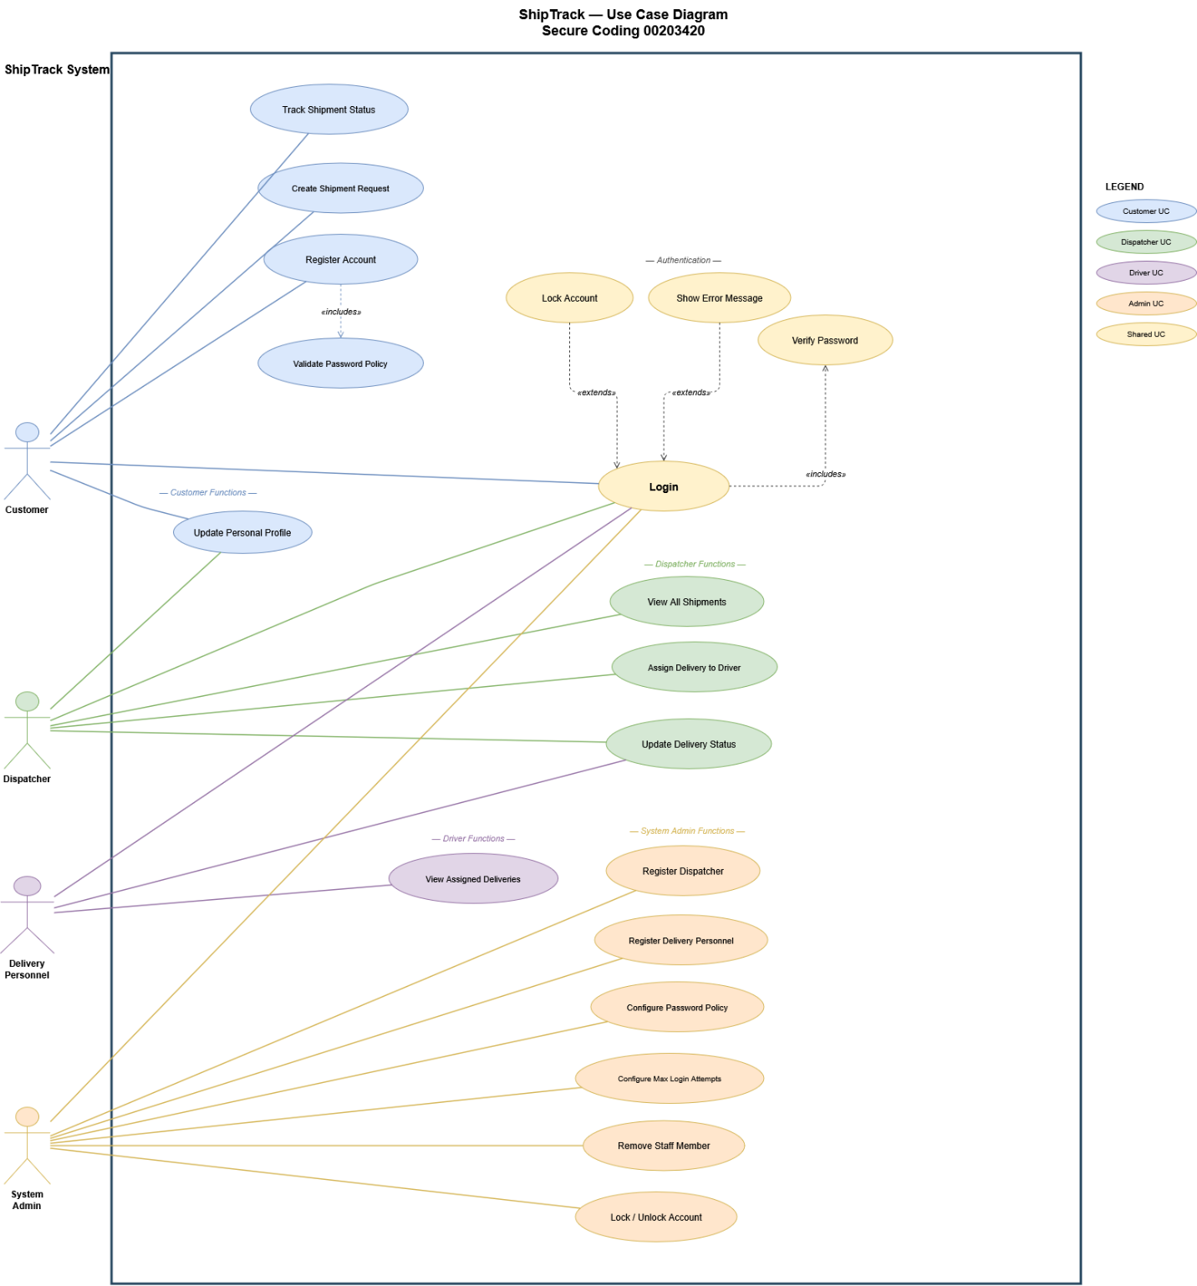

Figure 1: ShipTrack use-case diagram

ShipTrack — Use Case Tabular Descriptions
the tabular use-case descriptions for the six most important use cases in the ShipTrack system. Each table follows this format : use-case name, primary/secondary actors, description, pre-condition, post-condition, main flow, and alternative flows. Where relevant, alternative flows incorporate the misuse-case mitigations .

UC1 — Login
Use Case Description — Login (UC1)
Use case name | Login | Use case # | 1
Primary actors | Any registered user (Admin, Dispatcher, Customer, Delivery Personnel) | Secondary actors | None
Description | Authenticate the user’s identity against the credential store and dispatch control to the correct role menu. This is the gateway to the entire system; all other use cases require a prior successful login.
Pre-condition | A user account exists in data/users.dat and is not locked. The application is running.
Post-condition | The authenticated user is presented with their role-specific menu (AdminMenu, DispatcherMenu, CustomerMenu, or DriverMenu). A timestamped entry is written to data/audit.log recording the username and outcome.
Main flow | 1. The user enters a username at the console prompt.  2. The user enters a password.  3. The system triggers Verify Password — UC1a («includes»): decodes the stored PBKDF2 salt from users.dat, re-derives the 256-bit key from the candidate password using PBKDF2WithHmacSHA256 at 65,536 iterations, and compares the result to the stored hash in constant time (XOR-all-bytes).  4. The system resets the failed-attempt counter to 0 and persists the update atomically.  5. The system dispatches control to the role menu: Admin → AdminMenu — Dispatcher → DispatcherMenu — Customer → CustomerMenu — Delivery Personnel → DriverMenu.
Alternative flow | 2.a — Invalid username or password (Show Error Message «extends» Login)  1. The system displays: “Invalid username or password.” (Identical message whether username is unknown or password is wrong — prevents username enumeration.)  2. The system increments the failed-attempt counter and persists it.  3. The use case resumes at step 1.  2.b — Maximum login attempts exceeded (Lock Account «extends» Login)  1. The system detects that failedAttempts ≥ policy.maxLoginAttempts.  2. The system sets user.locked = true and persists atomically.  3. The system displays: “Account is locked. Contact the System Admin.”  4. The use case ends. The user cannot log in even with the correct password until an Admin unlocks the account via UC6 (Lock / Unlock Account).

UC2 — Register Account
Use Case Description — Register Account (UC2)
Use case name | Register Account | Use case # | 2
Primary actors | Customer (self-registers via App); System Admin (registers Dispatcher / Delivery Personnel via AdminMenu) | Secondary actors | None
Description | Create a new user account with a securely hashed password. The registration logic is shared for all roles; the difference is who initiates it and which role enum value is assigned. Customers self-register; Staff are registered by the Admin.
Pre-condition | The desired username does not already exist in data/users.dat.
Post-condition | A new pipe-delimited record is appended to data/users.dat containing: username | role | Base64-salt | Base64-PBKDF2-hash | false (locked) | 0 (attempts) | fullName | idNumber | contactNumber. An audit entry records the event and actor.
Main flow | 1. The actor enters: username, full name, ID number, and contact number.  2. The actor enters a chosen password.  3. The system triggers Validate Password Policy («includes»): checks that the password satisfies all six thresholds in PasswordPolicy (minLength, minUppercase, minLowercase, minDigits, minSpecial, loaded from data/policy.cfg).  4. The system validates the username against the regex ^[A-Za-z0-9._-]{3,20}$ and checks that all fields pass InputValidator.isStorageSafe() (no pipe character, newlines, or control characters).  5. The system calls PasswordHasher.hashWithNewSalt(): generates a fresh 16-byte SecureRandom salt and PBKDF2 hash.  6. The system creates a User object and writes it atomically to data/users.dat via temp-file-rename (Reliability principle).  7. The system confirms: “Registration successful.”
Alternative flow | 3.a — Password violates policy  1. The system displays which rule was violated (e.g. “Need at least 1 special character.”).  2. the use case ends; the user must restart registration from step 1.  4.a — Username already taken  1. The system displays “Username already taken.”  2. The use case resumes at step 1.  4.b — Invalid username format  1. The system displays “Invalid username.”  2. The use case resumes at step 1.

UC3 — Create Shipment Request
Use Case Description — Create Shipment Request (UC3)
Use case name | Create Shipment Request | Use case # | 3
Primary actors | Customer | Secondary actors | None
Description | A Customer submits a new package delivery request. The shipment is created with status PENDING and assigned a unique ID. No driver is assigned yet — the Dispatcher performs that in UC4.
Pre-condition | The Customer has completed UC1 (Login) successfully. The Customer’s account is not locked.
Post-condition | A new Shipment record with status PENDING is written atomically to data/shipments.dat. An audit entry records the shipment ID and the actor’s username. The Customer sees the new shipment ID on screen.
Main flow | 1. The Customer selects “Create shipment request” from CustomerMenu.  2. The Customer enters a free-text package description.  3. The system validates the description: not empty, ≤ 200 characters, passes InputValidator.isStorageSafe() (rejects pipe characters and control characters that could corrupt the file parser).  4. The system generates a unique shipment ID using ShipmentRepository.nextId() (format: S¬NNNN¬-¬TIMESTAMP).  5. The system creates a Shipment object: status = PENDING, customerUsername = logged-in user, driverUsername = empty, createdAt = now.  6. The system writes the Shipment record atomically to data/shipments.dat and writes an audit entry.  7. The system confirms: “Created shipment [ID] (status: pending).”
Alternative flow | 3.a — Description fails validation  1. The system displays: “Description is required and must be storage-safe (no ‘|’, newlines, control chars), up to 200 chars.”  2. The use case resumes at step 2.

UC4 — Assign Delivery to Driver
Use Case Description — Assign Delivery to Driver (UC4)
Use case name | Assign Delivery to Driver | Use case # | 4
Primary actors | Dispatcher | Secondary actors | None
Description | A Dispatcher assigns an existing PENDING shipment to a Delivery Personnel account. This links the shipment to the driver and enables the driver to update its status in UC5.
Pre-condition | The Dispatcher has completed UC1 (Login). The shipment exists in data/shipments.dat. The target username exists in data/users.dat and has role DELIVERY_PERSONNEL.
Post-condition | The shipment record in data/shipments.dat has the driver’s username populated in the driverUsername field. An audit entry records the shipment ID, the assigning Dispatcher, and the assigned driver.
Main flow | 1. The Dispatcher selects “Assign delivery to driver” from DispatcherMenu.  2. The Dispatcher enters the shipment ID.  3. The system retrieves the Shipment from data/shipments.dat.  4. The Dispatcher enters the driver’s username.  5. The system verifies the username exists in users.dat and that user.getRole() == DELIVERY_PERSONNEL. (Least Privilege check: a Dispatcher cannot assign a fellow Dispatcher or a Customer as a driver.)  6. The system calls Shipment.assignDriver(driverUsername) setting the driverUsername field.  7. The system writes the updated Shipment record atomically to data/shipments.dat and logs the event.  8. The system confirms: “Assigned [shipmentID] to [driverUsername].”
Alternative flow | 3.a — Shipment ID not found  1. The system displays “No such shipment.” The use case ends.  5.a — Username not found or not a Delivery Personnel  1. The system displays “That user is not a delivery person.”  2. The use case ends.

UC5 — Update Delivery Status
Use Case Description — Update Delivery Status (UC5)
Use case name | Update Delivery Status | Use case # | 5
Primary actors | Dispatcher; Delivery Personnel | Secondary actors | None
Description | Advance a shipment’s status through the permitted state machine.  Allowed transitions by role:  Dispatcher : PENDING → IN_TRANSIT → DELIVERED  Driver : PENDING → PICKED_UP → IN_TRANSIT → DELIVERED  Illegal backward transitions (e.g. DELIVERED → PENDING) are rejected by ShipmentStatus.canMoveTo().
Pre-condition | The actor is logged in. For Delivery Personnel: the shipment’s driverUsername matches the logged-in user (Least Privilege check). The current status permits the requested transition per the state machine.
Post-condition | The shipment’s status field is updated in data/shipments.dat atomically. An audit entry records the actor, shipment ID, and new status.
Main flow | 1. The actor selects “Update delivery status” from their role menu.  2. The actor enters the shipment ID.  3. The system retrieves the Shipment from data/shipments.dat.  4. [Driver only] The system checks that shipment.getDriverUsername().equals(loggedInUser). If not, go to alternative flow 4.a.  5. The actor enters the desired new status label (e.g. “in transit”).  6. The system calls ShipmentStatus.fromString() to parse the input.  7. The system calls Shipment.advanceTo(newStatus). The method delegates to ShipmentStatus.canMoveTo() which enforces the transition rules.  8. The system writes the updated Shipment atomically and logs the event.  9. The system confirms: “Status updated.”
Alternative flow | 4.a — Driver tries to update another driver’s shipment  1. The system displays “That shipment is not assigned to you.”  2. An AUDIT WARN entry is written (Repudiation mitigation).  3. The use case ends.  6.a — Unrecognised status label  1. The system displays “Invalid status.” The use case ends at step 5.  7.a — Illegal state machine transition  1. The system displays “Illegal transition from [current] to [requested].”  2. The use case ends. No write occurs; the old status is preserved.

UC6 — Configure Password Policy
Use Case Description — Configure Password Policy (UC6)
Use case name | Configure Password Policy | Use case # | 6
Primary actors | System Admin | Secondary actors | None
Description | The System Admin defines the application-wide password strength rules: minimum length, minimum uppercase/lowercase/digit/special-character counts, and maximum login attempts. Changes persist to data/policy.cfg and take effect for all subsequent registrations and password changes immediately.
Pre-condition | The System Admin is logged in. No other role can reach this use case (Least Privilege: only the ADMIN enum value is dispatched to AdminMenu in App.java).
Post-condition | The PasswordPolicy object is updated in memory. All six threshold values are written to data/policy.cfg as key=value pairs. Subsequent calls to PasswordPolicy.isAcceptable() and AuthService.login() (lockout threshold) use the new values. An audit entry records the new policy string.
Main flow | 1. The Admin selects “Define password policy” from AdminMenu.  2. The system prompts for minimum password length.  3. The system prompts for minimum uppercase letters.  4. The system prompts for minimum lowercase letters.  5. The system prompts for minimum digits.  6. The system prompts for minimum special characters.  7. The system calls the corresponding setter on PasswordPolicy (e.g. setMinLength()). Each setter clamps the value to a safe range (1–64 for length, 0–20 for character counts) — a typo cannot produce an absurd or insecure policy.  8. The system calls PasswordPolicy.save() to write all six values to data/policy.cfg.  9. The system displays the updated policy string for confirmation.
Alternative flow | 7.a — Admin enters a negative or out-of-range value  1. The system silently clamps the value to its permitted range (e.g. -1 → 1; 9999 → 20).  2. The use case continues at the next prompt. No crash, no error message — Quality principle: Reliability (Fail Securely on bad input even from a trusted actor).  Note on UC6b — Configure Max Login Attempts  The Admin can also select “Define max login attempts” from AdminMenu. This follows an identical flow using PasswordPolicy.setMaxLoginAttempts(), clamped to 1–20, and saved to the same policy.cfg file. It is listed as a separate use case in the diagram to reflect the separate brief requirement, but shares the same PasswordPolicy.save() mechanism.

3.2 Misuse Case Diagram
The misuse-case diagram below identifies the threats most relevant to the Login and Account-Management use cases, and links each threat to the mitigation actually implemented in the code. The misuser is shown to the right of the system rectangle, mirroring the legitimate actors on the left.

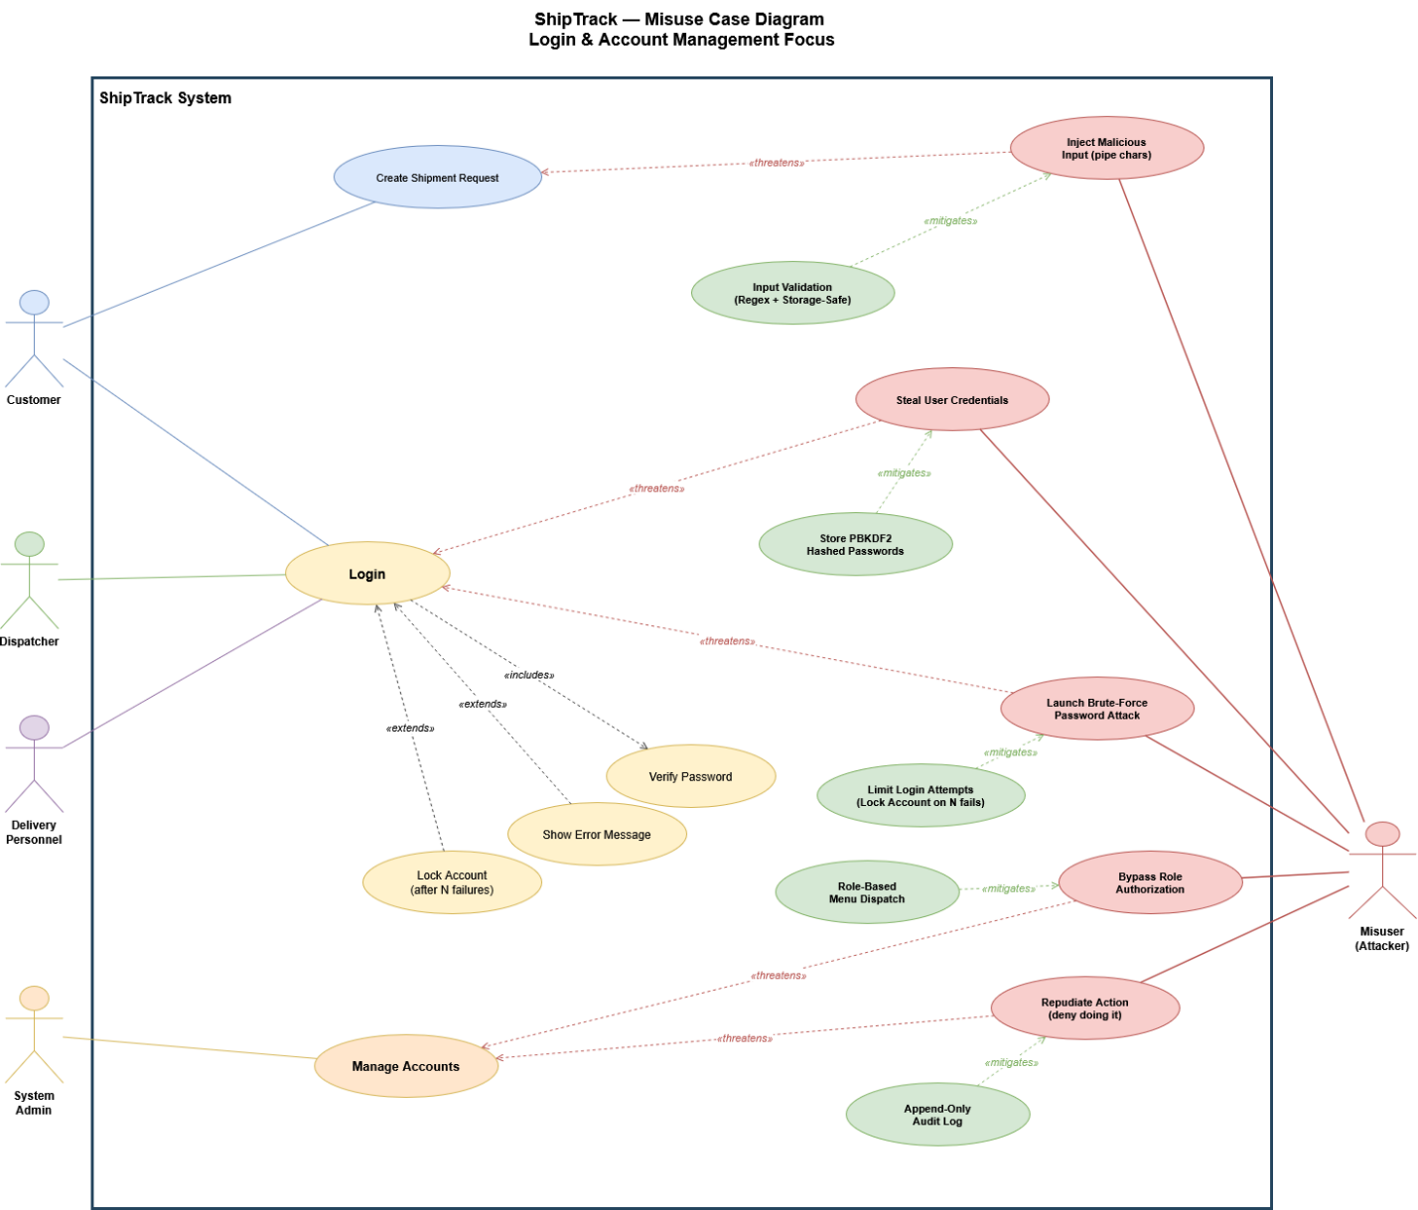
Figure 2: ShipTrack misuse-case diagram

The misuse cases above guided the threat-model decisions in Section 5 (Q4-Q6) and the security testing in Section 9 (Q10).

Complete element-by-element explanation
what every element means:
Element | Visual | rule | ShipTrack example
System rectangle | Large bordered box | Everything inside = happens in the system; outside = external | The ShipTrack System box containing all 19 use cases
Actor (stick figure) | Outside the rectangle | Represents a role, not a person. Primary = initiates the use case | Customer, Dispatcher, Delivery Personnel, System Admin
Use case (oval) | Inside the rectangle | A verb + object describing a goal the actor achieves | "Create Shipment Request", "Login", "Configure Password Policy"
Association (solid line) | Connects actor to oval | The actor interacts with that use case | Customer — Login, Customer — Track Shipment Status
«includes» (dashed → included) | Dashed arrow pointing TO the included use case | The included use case ALWAYS runs as part of the base | Login «includes» Verify Password — every login always verifies the password
«extends» (dashed → base) | Dashed arrow pointing TO the base | The extension runs ONLY under certain conditions | Show Error Message «extends» Login — only fires when credentials are wrong
Misuser (dark stick figure) | Outside the system, right side | The attacker role — Ch.4 slide 26 | "Attacker" who initiates misuse cases
Misuse case (red oval) | Inside or at system boundary | A sequence of actions that can harm the system — Ch.4 slide 26 | "Launch Brute-Force Password Attack"
«threatens» (red dashed → use case) | From misuse case toward the threatened use case | Identifies which use case is at risk — Ch.4 slide 31 | "Steal User Credentials" «threatens» Login
«mitigates» (green dashed → misuse) | From countermeasure toward the misuse case it prevents | The security control that defeats the attack — Ch.4 slide 31 | "Store PBKDF2 Hashed Passwords" «mitigates» "Steal User Credentials"
Countermeasure (green oval) | Inside system, center column | A new use case created specifically to counter a misuse case — Ch.4 slide 19: "Every countermeasure created is a new software requirement" | "Limit Login Attempts (Lock on N failures)" — this is what became AuthService.login() Layer 3

4. Q4-Q6 — Threat Modeling (DFD, STRIDE, Report)
Per the brief, the Q4 (DFD), Q5 (threats per category), and Q6 (full threat-model report) deliverables are submitted as separate files: ShipTrack.tm7 and ShipTrack-ThreatReport.html. This section provides a brief summary of the model so the report stands on its own; the canonical artefacts are the two files.

4.1 Summary of the Data Flow Diagram (Q4)

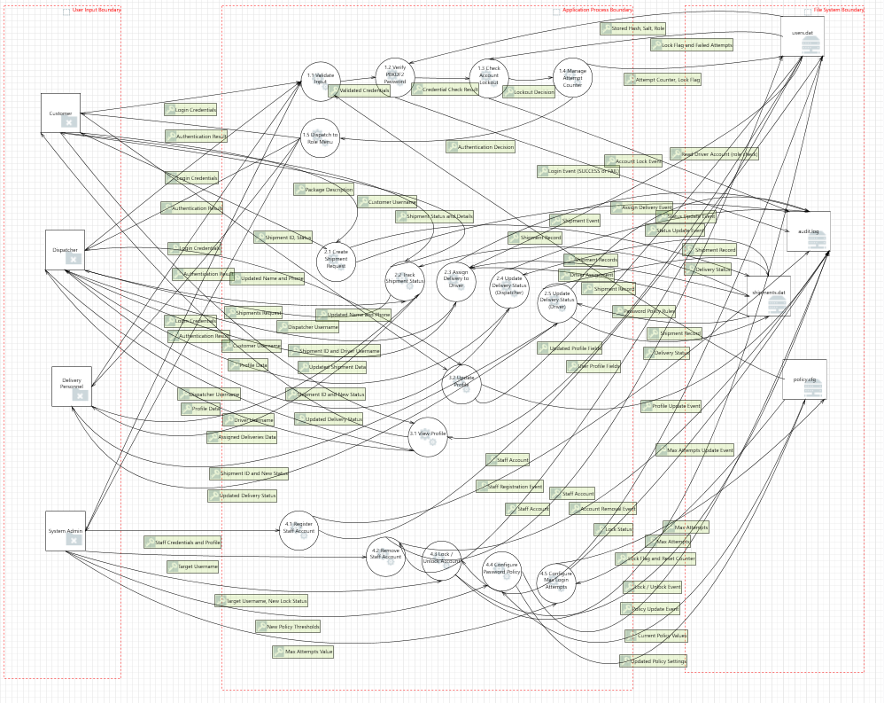
Figure 3: ShipTrack data-flow diagram (Microsoft Threat Modeling Tool)

4.2 Threat Enumeration per STRIDE Category (Q5)
The Microsoft Threat Modeling Tool was used to generate threats for each STRIDE category. The brief requires at least 10 threats per category. The summary counts below were produced by the tool; the per-threat detail (description, justification, status, mitigation) is in the generated HTML report.
STRIDE Category | # Threats | Representative example threat and mitigation
S — Spoofing | 92 | Attacker impersonates a Customer at the console. Mitigation: PBKDF2-hashed password verification in AuthService.login().
T — Tampering | 35 | Modification of users.dat on disk. Mitigation: file-system ACLs + atomic writes + audit log of every change.
R — Repudiation | 117 | A user denies issuing a shipment-creation command. Mitigation: append-only audit.log timestamps every action with the actor.
I — Information Disclosure | 13 | Plaintext password leakage via a stack trace. Mitigation: top-level try/catch in App.main converts exceptions to a generic message + audit-log entry.
D — Denial of Service | 161 | Unbounded input causes the Shipment Service to allocate excessive memory. Mitigation: 200-character cap on shipment description; PBKDF2 limits the cost of a single login.
E — Elevation of Privilege | 110 | A Customer reaches the Admin menu by manipulating role state. Mitigation: role is final on User and is read from disk — it cannot be re-set in memory by any UI code.

4.3 Threat-Model Report (Q6)
The full report — every threat, its description, justification, status, and chosen mitigation — was generated by the Microsoft Threat Modeling Tool and is submitted alongside this document as ShipTrack-ThreatReport.html. The mitigations selected follow the standard mitigation table in Chapter 6: authentication for spoofing, ACLs and digital signatures for tampering, secure logging for repudiation, encryption and ACLs for information disclosure, filtering and quotas for denial of service, and input validation plus role checking for elevation of privilege.

5. Q7 — Testing Methods for User Satisfaction

software testing is important for four reasons: it is cost effective, it ensures product quality, it achieves customer satisfaction, and it maintains security. Testing falls into three main categories: Functional Testing, Non-Functional Testing, and Maintenance Testing. The following methods drawn from those categories are appropriate for evaluating whether ShipTrack satisfies its users and meets its requirements.

7.1 User Acceptance Testing (UAT) — Functional Testing

User Acceptance Testing is where the software is tested in the "real world" by the intended audience or business representative. For ShipTrack, the actual dispatchers and customers from SkyRoute Solutions would walk through creating shipments, assigning deliveries, and tracking packages against the agreed acceptance criteria.
Benefit: UAT is the direct contractual proof that the requirements specified in the brief have been met. It surfaces gaps between what was written in the specification and what users actually need in practice, and it builds user confidence before the application is deployed.

7.2 Usability Testing — Non-Functional Testing

usability testing is a method of testing the functionality of an application by observing real users as they attempt to complete tasks on it. For ShipTrack, representative users from each role (Customer, Dispatcher, Driver) would be observed completing realistic tasks such as registering an account or assigning a delivery.
Benefit: identifies confusing menus, unclear error messages, or unnecessary interaction steps before they become problems in production. It provides direct evidence of whether the application's interface and error messages satisfy users in practice.

7.3 Integration Testing — Functional Testing
integration testing is a type of testing where software modules are integrated logically and tested as a group. For ShipTrack, this means testing that the authentication module, the shipment module, and the repository module work correctly when connected together — for example, verifying that a Customer who registers can then log in and create a shipment in a single end-to-end flow.
Benefit: ensures that the modules that individually passed unit testing continue to meet requirements when combined, and catches interface mismatches between components that users would encounter in real use.

7.4 Performance Testing — Non-Functional Testing
performance testing is the practice of evaluating how a system performs in terms of responsiveness and stability under a particular workload. It examines speed, robustness, reliability, and application size. For ShipTrack, this means testing that login, shipment creation, and status updates respond within an acceptable time even when many shipments exist in the data file.
Benefit: confirms that the system meets the non-functional requirements around responsiveness that affect user satisfaction. A system that is functionally correct but slow will not satisfy users.

7.5 Load Testing — Non-Functional Testing
load testing is the practice of modelling the expected usage of a software program by simulating multiple users accessing the program concurrently. For ShipTrack, this means simulating multiple concurrent users performing login and shipment operations to verify the file-locking and atomic-write mechanisms hold under simultaneous access.
Benefit: reveals whether the application meets its requirements under the realistic usage levels expected from SkyRoute Solutions, not just under single-user development conditions.

7.6 Regression Testing — Maintenance Testing
regression testing is a type of testing that runs after every change to ensure that the change introduces no unintended breaks. For ShipTrack, the JUnit test suite of 106 test cases would be re-run after any code change or bug fix to verify that previously satisfied requirements still pass.
Benefit: ensures that as the application evolves to address user feedback, earlier requirements that were already accepted do not silently break. It protects the confidence that users have built up through UAT.

6. Q8 — Security Testing Methods

security testing is divided into two main categories: Static Analysis Security Testing (SAST) and Dynamic Analysis Security Testing (DAST). Both categories were applied to ShipTrack

Static Analysis Security Testing (SAST)
SAST involves executing methods and techniques to test the code without actually running the application. It does not evaluate the application's performance; instead, it evaluates what the actual code looks like on paper. SAST includes two techniques:

8.1.1 Static Code Analysis
static code analyzers scan (parse) through static code and analyse the code base for security vulnerabilities such as buffer overflows. Chapter 10 lists several tools available on the market, including CodeQL, Microsoft DevSkim, VSTS security marketplace, Checkmarx, and PMD. These tools come with sophisticated code parsers and also have reporting features.

For ShipTrack, PMD version 7.24.0 with the java/quickstart.xml ruleset was used (Q11). The initial run identified 61 violations across 16 source files including empty catch blocks, missing control statement braces, and locale-insensitive string comparisons. After fixes were applied, the violation count was reduced to 10 (the remaining violations were intentional design decisions).
Benefit: finds defects in the source code without needing a deployed environment; catches security anti-patterns such as silently swallowed exceptions (EmptyCatchBlock) and potential NullPointerExceptions (LiteralsFirstInComparisons) before the code is ever executed.

8.1.2 Code Reviews and Inspections
code reviews are people-intensive verification techniques conducted either formally or informally that allow peers to read code statements and look for common security vulnerabilities, such as hard-coded IDs or passwords, and general quality features. code reviews conducted correctly should have a very positive effect on the team, and that reviewing code as a team is a great opportunity for skilled developers to share knowledge with entry-level developers.

For ShipTrack, the PMD output was reviewed manually to confirm that each flagged violation was either fixed correctly or justified by a deliberate security design decision (such as the top-level Throwable catch that implements Fail Securely).
Benefit: catches design-level issues that automated tools cannot reason about, such as whether the intent behind a catch block is correct, and transfers security knowledge across the team.

8.2 Dynamic Analysis Security Testing (DAST)
dynamic testing implies executing the current use case using valid inputs and then comparing the real results with expected results for pass or failures. Every method requires the tester to analyse the results, perform validation and verification (V&V) on the software, and report the findings. DAST includes four techniques:

8.2.1 Fuzz Testing
fuzz testing is a technique that feeds random input data into applications just to see what happens to the results. It considers runtime errors and buffer overflows. Fuzzing can be done using tools or human methods that write garbage data into enterable fields. To carry out a fuzz test: enter random data into part of the input, execute the application with that input, evaluate the results, and number each test case and report findings.
For ShipTrack, the Jazzer coverage-guided fuzzer was used (Q10). Two fuzzers were written: LoginFuzzer targeting AuthService.login(), PasswordHasher.verify(), and PasswordPolicy.describeViolations(); and ShipmentFuzzer targeting ShipmentStatus.fromString(), Shipment.advanceTo(), and Shipment.fromRecord(). Both ran 10,000 iterations and completed with zero findings.
Benefit: discovers edge cases that human testers and unit tests would never write; explicitly tests the application's ability to Fail Securely (Ch.2) by confirming that no random input causes an unhandled exception.

8.2.2 Reliability Testing
reliability of an application is when the application produces correct results despite being under attack or under extreme use. Testing the reliability of the application requires simulation tools that can replicate the number of expected uses, time of day, and software environment as in the real world.
For ShipTrack, reliability is evidenced by the fuzz testing runs (10,000 random iterations with zero failures) and by the 106-test JUnit suite which validates correct results for all boundary conditions.
Benefit: demonstrates that ShipTrack produces correct authentication and shipment management results even when fed arbitrary, unexpected input — providing confidence in production reliability.

8.2.3 Resiliency Testing
coding for resiliency means accepting the fact that something bad will happen and that when it does, you will be ready. Resiliency testing covers two aspects: knowing how to bounce back (what to do when something goes wrong, who to call) and making something bad happen (testing dependencies and recovery time).
For ShipTrack, resiliency is built into the code through atomic file writes (ATOMIC_MOVE), which means a crash during a write leaves either the old or new file intact and never a corrupted half-written file. The append-only audit.log provides the recovery evidence needed to know what happened.
Benefit: confirms that the application can recover from partial failures without losing data integrity, and that the audit log provides the evidence needed to diagnose and respond to incidents.

8.2.4 Penetration Testing
penetration testing (also known as pen testing) is a security exercise where a cyber-security expert attempts to find and exploit vulnerabilities in a computer system. The purpose of this simulated attack is to identify any weak spots in a system's defences which attackers could take advantage of.
For ShipTrack, penetration testing would involve a tester attempting to bypass the login lockout by timing attacks, injecting pipe characters into shipment descriptions to corrupt data files, and attempting to access another customer's shipments through the console interface.
Benefit: combines tools, knowledge, and creativity in a way that no automated method can; produces a prioritised list of exploitable findings rather than a list of code smells; and verifies that the security controls actually stop attacks rather than just asserting that they should.

7. Q9 — Quality-Based Testing (JUnit Test Plan)

7.1 Test Plan Table

ID | What to Test | Description (Inputs) | Expected | Actual | Status
FEATURE 1 — LOGIN / AUTHENTICATION
AuthService — Input Validation Layer
1 | AuthService.login() | Null password, valid username | BAD_INPUT outcome, user=null | BAD_INPUT outcome, user=null | Pass
2 | AuthService.login() | Empty password (char[0]), valid username | BAD_INPUT outcome | BAD_INPUT outcome | Pass
3 | AuthService.login() | Username too short ("ab"), valid password | BAD_INPUT outcome | BAD_INPUT outcome | Pass
4 | AuthService.login() | Username with space ("has space"), valid password | BAD_INPUT outcome | BAD_INPUT outcome | Pass
5 | AuthService.login() | Username with pipe ("has|pipe"), valid password | BAD_INPUT outcome | BAD_INPUT outcome | Pass
6 | AuthService.login() | Username too long (>20 chars), valid password | BAD_INPUT outcome | BAD_INPUT outcome | Pass
7 | AuthService.login() | Null username, valid password | BAD_INPUT outcome | BAD_INPUT outcome | Pass
8 | AuthService.login() | Empty string username (""), valid password | BAD_INPUT outcome | BAD_INPUT outcome | Pass
AuthService — Existence Check / Enumeration Defence
9 | AuthService.login() | Unknown username "nobody", valid password | BAD_CREDENTIALS outcome, user=null | BAD_CREDENTIALS outcome, user=null | Pass
10 | AuthService.login() | Unknown user vs wrong password — compare messages | Both messages must be identical | Messages are identical | Pass
AuthService — Account Lockout Layer
11 | AuthService.login() | Locked account with correct password | ACCOUNT_LOCKED outcome, message contains "locked" | ACCOUNT_LOCKED outcome | Pass
12 | AuthService.login() | Wrong password × maxAttempts (3), then correct password | Account locked, ACCOUNT_LOCKED on 4th call | Account locked | Pass
13 | AuthService.login() | Wrong password × 1, check counter | failedAttempts=1, isLocked=false | failedAttempts=1, isLocked=false | Pass
14 | AuthService.login() | Wrong password × 2, check counter | failedAttempts=2, isLocked=false | failedAttempts=2, isLocked=false | Pass
15 | AuthService.login() | Wrong password × (maxAttempts-1) — should not lock yet | isLocked=false | isLocked=false | Pass
AuthService — PBKDF2 Verification Layer
16 | AuthService.login() | Valid username and correct password | OK outcome, user!=null, role=CUSTOMER | OK outcome, user returned | Pass
17 | AuthService.login() | Valid username, wrong password (before lockout) | BAD_CREDENTIALS, user=null, not locked | BAD_CREDENTIALS | Pass
18 | AuthService.login() | All 4 roles log in with correct credentials | OK outcome with correct role for each | OK, correct role returned | Pass
19 | AuthService.login() | Default bootstrap admin with default password "Admin@123" | OK outcome | OK outcome | Pass
AuthService — Result Messages
20 | AuthService.login() | Successful login — check welcome message | Message contains "welcome" or user's name | Message contains greeting | Pass
21 | AuthService.login() | BAD_INPUT message — must not leak internals | Message does not contain "exception" or "null" | No internals exposed | Pass
22 | AuthService.login() | ACCOUNT_LOCKED message — check content | Message mentions "admin" or "locked" | Correct guidance message | Pass
AuthService — changePassword
23 | AuthService.changePassword() | Valid new password "NewSecure9!" | Returns true; new password works; old password fails | Returns true | Pass
24 | AuthService.changePassword() | Weak password "weak" (violates policy) | Returns false; old password still works | Returns false | Pass
25 | AuthService.changePassword() | Null user parameter | Returns false | Returns false | Pass
26 | AuthService.changePassword() | Null password parameter | Returns false | Returns false | Pass
PasswordHasher — hashWithNewSalt
27 | PasswordHasher.hashWithNewSalt() | Password "TestPass1!" | Returns String[2] (not null) | String[2] returned | Pass
28 | PasswordHasher.hashWithNewSalt() | Password "TestPass1!" — check salt length | Salt decodes to 16 bytes | 16 bytes | Pass
29 | PasswordHasher.hashWithNewSalt() | Password "TestPass1!" — check hash length | Hash decodes to 32 bytes (256 bits) | 32 bytes | Pass
30 | PasswordHasher.hashWithNewSalt() | Same password called twice | Salts and hashes differ (random salt) | Salts and hashes differ | Pass
PasswordHasher — verify
31 | PasswordHasher.verify() | Correct password against its own hash | Returns true | Returns true | Pass
32 | PasswordHasher.verify() | Wrong password "WrongPass9!" against stored hash | Returns false | Returns false | Pass
33 | PasswordHasher.verify() | Empty char[] against stored hash | Returns false | Returns false | Pass
34 | PasswordHasher.verify() | Same password different case ("testpass1!" vs "TestPass1!") | Returns false (case-sensitive) | Returns false | Pass
35 | PasswordHasher.verify() | Password with one extra character appended | Returns false | Returns false | Pass
36 | PasswordHasher.verify() | Called twice with same inputs (determinism) | Both return true | Both return true | Pass
37 | PasswordHasher.verify() | Invalid Base64 salt "!!!NOT_BASE64!!!" | Returns false (no exception thrown) | Returns false | Pass
38 | PasswordHasher.verify() | Invalid Base64 hash "!!!NOT_BASE64!!!" | Returns false (no exception thrown) | Returns false | Pass
PasswordHasher — newSalt / derive
39 | PasswordHasher.newSalt() | Called twice | Two results are not equal; each is 16 bytes | Different salts, 16 bytes each | Pass
40 | PasswordHasher.derive() | Same password and salt, called twice | Both results are identical (deterministic) | Identical results | Pass
PasswordPolicy — Default Values
41 | PasswordPolicy defaults | No arguments constructor | minLength=8 | 8 | Pass
42 | PasswordPolicy defaults | No arguments constructor | minUppercase=1, minLowercase=1, minDigits=1, minSpecial=1 | All =1 | Pass
43 | PasswordPolicy defaults | No arguments constructor | maxLoginAttempts=3 | 3 | Pass
PasswordPolicy — Compliant Passwords
44 | PasswordPolicy.describeViolations() | "TestPass1!" (length=10, 1U, 7L, 1D, 1S) | Returns null (no violations) | null | Pass
45 | PasswordPolicy.isAcceptable() | "TestPass1!" | Returns true | true | Pass
46 | PasswordPolicy.isAcceptable() | "Abcde1!x" (exactly at all thresholds) | Returns true | true | Pass
PasswordPolicy — Individual Violations
47 | PasswordPolicy.describeViolations() | "Short1!" (7 chars, min=8) | Not null; message contains "characters" | Violation reported | Pass
48 | PasswordPolicy.describeViolations() | "testpass1!" (no uppercase) | Not null; message contains "uppercase" | Violation reported | Pass
49 | PasswordPolicy.describeViolations() | "TESTPASS1!" (no lowercase) | Not null; message contains "lowercase" | Violation reported | Pass
50 | PasswordPolicy.describeViolations() | "TestPass!!" (no digit) | Not null; message contains "digit" | Violation reported | Pass
51 | PasswordPolicy.describeViolations() | "TestPass11" (no special char) | Not null; message contains "special" | Violation reported | Pass
52 | PasswordPolicy.describeViolations() | null password | Returns non-null message | Non-null message | Pass
PasswordPolicy — Multiple Violations
53 | PasswordPolicy.describeViolations() | Empty char[] | Not null; mentions "characters" | Violations reported | Pass
54 | PasswordPolicy.describeViolations() | "a" (single lowercase) | At least 4 violation lines | ≥4 violations | Pass
PasswordPolicy — Boundary
55 | PasswordPolicy.isAcceptable() | Password exactly (minLength-1) chars long | Returns false | false | Pass
56 | PasswordPolicy.isAcceptable() | "Abcde1!x" (exactly 8 chars, meets all) | Returns true | true | Pass
PasswordPolicy — Setter Clamping
57 | PasswordPolicy.setMinLength() | setMinLength(0) → getMinLength() | Returns 1 (clamped) | 1 | Pass
58 | PasswordPolicy.setMinLength() | setMinLength(-10) → getMinLength() | Returns 1 (clamped) | 1 | Pass
59 | PasswordPolicy.setMinLength() | setMinLength(999) → getMinLength() | Returns 64 (clamped) | 64 | Pass
60 | PasswordPolicy.setMaxLoginAttempts() | setMaxLoginAttempts(0) | Returns 1 (clamped) | 1 | Pass
61 | PasswordPolicy.setMaxLoginAttempts() | setMaxLoginAttempts(-5) | Returns 1 (clamped) | 1 | Pass
62 | PasswordPolicy.setMaxLoginAttempts() | setMaxLoginAttempts(999) | Returns 20 (clamped) | 20 | Pass
63 | PasswordPolicy — setters | setMinUppercase(-1), setMinLowercase(-5), setMinDigits(-3), setMinSpecial(-2) | All return 0 | All 0 | Pass
PasswordPolicy — Custom Thresholds
64 | PasswordPolicy.isAcceptable() | minUppercase=3, test "TestPass1!" (only 1 upper) | Returns false | false | Pass
65 | PasswordPolicy.isAcceptable() | minSpecial=0, test "TestPass11" (no special) | Returns true | true | Pass
66 | PasswordPolicy.toString() | Default policy object | Contains: len, upper, lower, digit, special, attempts | All 6 fields present | Pass
FEATURE 2 — SHIPMENT STATE MACHINE
ShipmentStatus — Legal Transitions
67 | ShipmentStatus.canMoveTo() | PENDING → PICKED_UP | Returns true | true | Pass
68 | ShipmentStatus.canMoveTo() | PENDING → IN_TRANSIT | Returns true | true | Pass
69 | ShipmentStatus.canMoveTo() | PICKED_UP → IN_TRANSIT | Returns true | true | Pass
70 | ShipmentStatus.canMoveTo() | PICKED_UP → DELIVERED | Returns true | true | Pass
71 | ShipmentStatus.canMoveTo() | IN_TRANSIT → DELIVERED | Returns true | true | Pass
ShipmentStatus — Illegal Transitions
72 | ShipmentStatus.canMoveTo() | PENDING → DELIVERED (skip) | Returns false | false | Pass
73 | ShipmentStatus.canMoveTo() | All 4 statuses → same status | Returns false for all 4 | false for all | Pass
74 | ShipmentStatus.canMoveTo() | PICKED_UP → PENDING (backward) | Returns false | false | Pass
75 | ShipmentStatus.canMoveTo() | IN_TRANSIT → PENDING (backward) | Returns false | false | Pass
76 | ShipmentStatus.canMoveTo() | IN_TRANSIT → PICKED_UP (backward) | Returns false | false | Pass
77 | ShipmentStatus.canMoveTo() | DELIVERED → PENDING, PICKED_UP, IN_TRANSIT, DELIVERED | All return false (terminal state) | All false | Pass
78 | ShipmentStatus.canMoveTo() | Any status → null | Returns false | false | Pass
79 | ShipmentStatus.canMoveTo() | Count all allowed transitions | Exactly 5 allowed transitions | 5 | Pass
ShipmentStatus — fromString Parsing
80 | ShipmentStatus.fromString() | "pending", "PENDING", "Pending" | Returns PENDING for all 3 | PENDING | Pass
81 | ShipmentStatus.fromString() | "picked up", "PICKED_UP", "picked-up", "Picked Up" | Returns PICKED_UP for all | PICKED_UP | Pass
82 | ShipmentStatus.fromString() | "in transit", "IN_TRANSIT", "in-transit", "IN TRANSIT" | Returns IN_TRANSIT for all | IN_TRANSIT | Pass
83 | ShipmentStatus.fromString() | "delivered", "DELIVERED", "Delivered" | Returns DELIVERED for all | DELIVERED | Pass
84 | ShipmentStatus.fromString() | "unknown", "dispatch", "sent", "", " " | Throws IllegalArgumentException for all | Exception thrown | Pass
85 | ShipmentStatus.fromString() | null | Throws IllegalArgumentException | Exception thrown | Pass
ShipmentStatus — Labels
86 | ShipmentStatus.label() | PENDING.label() | "pending" | "pending" | Pass
87 | ShipmentStatus.label() | PICKED_UP.label() | "picked up" (space, not underscore) | "picked up" | Pass
88 | ShipmentStatus.label() | IN_TRANSIT.label() | "in transit" (space, not underscore) | "in transit" | Pass
89 | ShipmentStatus.label() | DELIVERED.label() | "delivered" | "delivered" | Pass
ShipmentStatus — Completeness
90 | ShipmentStatus.values() | Count all enum values | Exactly 4 statuses | 4 | Pass
91 | ShipmentStatus round-trip | fromString(label()) for all 4 statuses | Each status recovers itself | All statuses recovered | Pass
Shipment — newRequest Factory
92 | Shipment.newRequest() | ID="S0001", customer="alice", desc="Fragile electronics" | status=PENDING | PENDING | Pass
93 | Shipment.newRequest() | Same inputs as above | id="S0001" | "S0001" | Pass
94 | Shipment.newRequest() | Same inputs | customerUsername="alice" | "alice" | Pass
95 | Shipment.newRequest() | Same inputs | description="Fragile electronics" | "Fragile electronics" | Pass
96 | Shipment.newRequest() | No driver assigned yet | driverUsername="" (empty) | "" | Pass
97 | Shipment.newRequest() | Timestamp check | createdAt is not null and is within ±1 second of now | Recent timestamp | Pass
Shipment — assignDriver
98 | Shipment.assignDriver() | driver="bob" | driverUsername="bob" | "bob" | Pass
99 | Shipment.assignDriver() | Reassign from "driver1" to "driver2" | driverUsername="driver2" | "driver2" | Pass
100 | Shipment.assignDriver() | null | Throws IllegalArgumentException | Exception thrown | Pass
101 | Shipment.assignDriver() | Empty string "" | Throws IllegalArgumentException | Exception thrown | Pass
Shipment — advanceTo (State Machine)
102 | Shipment.advanceTo() | PENDING → IN_TRANSIT (valid) | Returns true; status=IN_TRANSIT | true, IN_TRANSIT | Pass
103 | Shipment.advanceTo() | PENDING → DELIVERED (illegal) | Returns false; status stays PENDING | false, PENDING | Pass
104 | Shipment.advanceTo() | DELIVERED → PENDING/PICKED_UP/IN_TRANSIT (terminal) | All return false; status stays DELIVERED | false, DELIVERED | Pass
105 | Shipment.advanceTo() | Full lifecycle: PENDING→PICKED_UP→IN_TRANSIT→DELIVERED | All 3 transitions return true | All true | Pass
106 | Shipment.advanceTo() | PENDING → IN_TRANSIT (dispatcher skips PICKED_UP) | Returns true | true | Pass
107 | Shipment.advanceTo() | PENDING → PENDING (same state) | Returns false | false | Pass
108 | Shipment.advanceTo() | null target | Returns false; status unchanged | false | Pass
Shipment — Serialisation
109 | Shipment.toRecord() | Any shipment | Record contains exactly 5 pipe separators (6 fields) | 5 pipes | Pass
110 | Shipment.fromRecord() | Full round-trip on all 6 fields | All fields restored identically | All fields match | Pass
111 | Shipment.toRecord() | Description containing pipe "Box|Important" | Pipe sanitised; record still has exactly 5 separators | 5 pipes | Pass
112 | Shipment.fromRecord() | Record with only 3 fields | Throws exception | Exception thrown | Pass

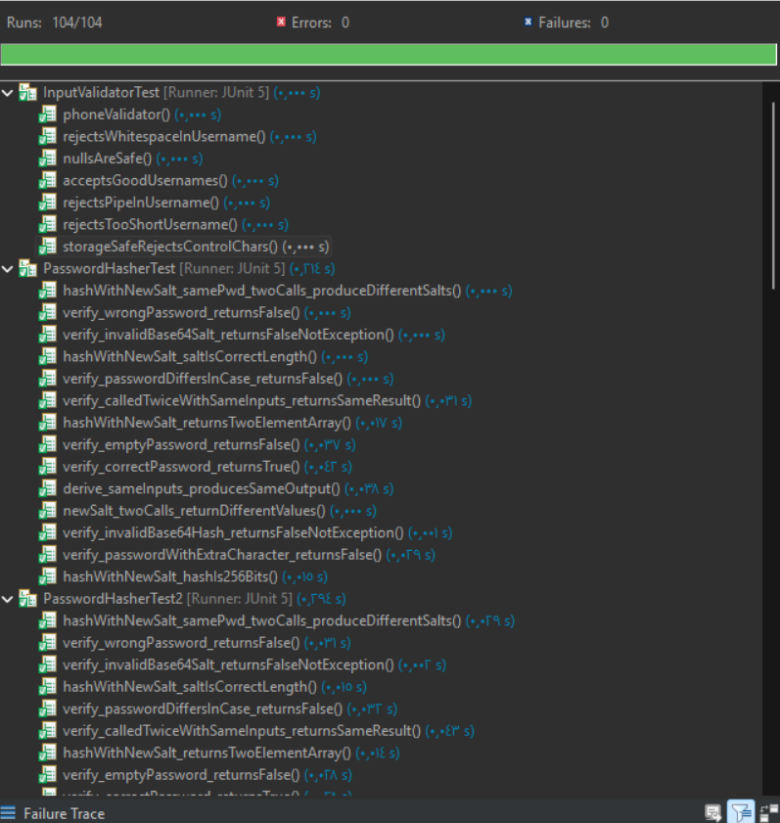
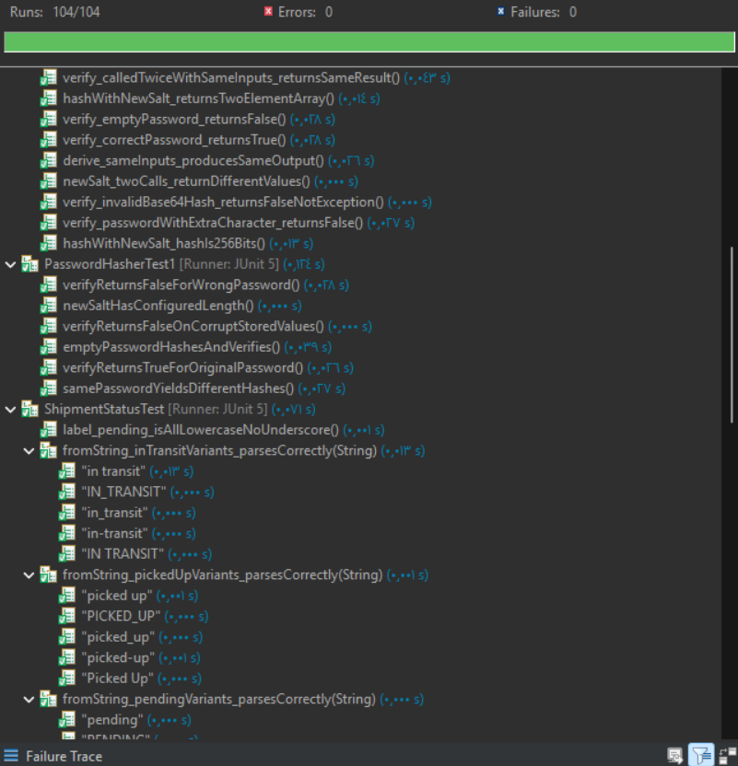
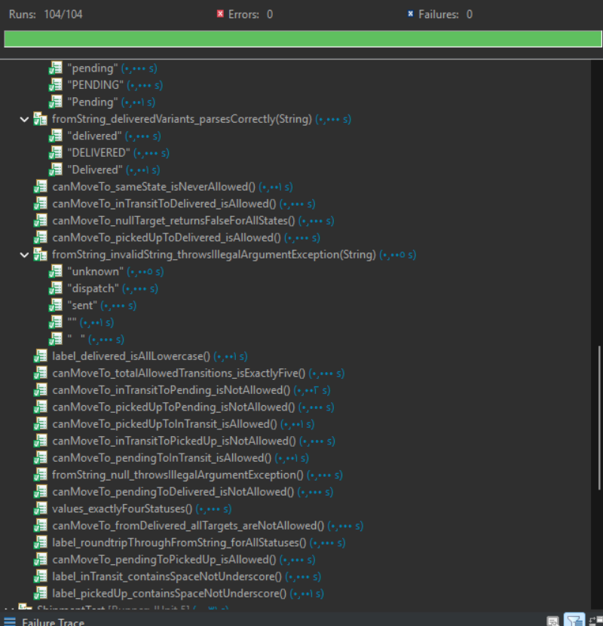
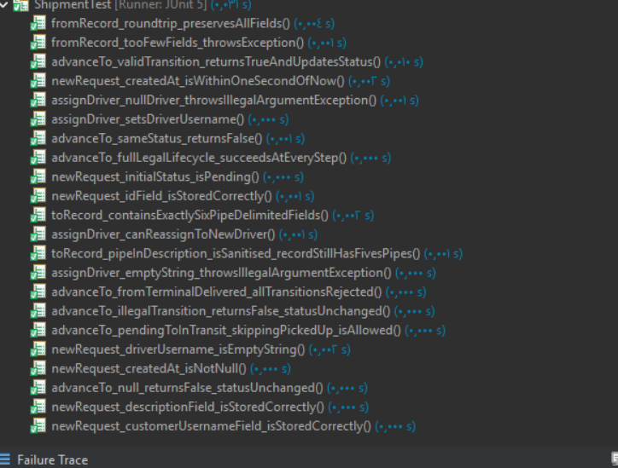

Figure 4: JUnit test execution result — 104 tests passed

8. Q10 — Security-Based Testing (Fuzz Testing)

10.1 Overview of Fuzz Testing
Fuzz testing, or fuzzing, is a Dynamic Analysis Security Testing (DAST) technique that feeds random input data into an application to observe how it behaves under unexpected or malformed inputs. As defined in the course material (Ch. 11), fuzzing considers runtime errors and considers conditions such as buffer overflows and unhandled exceptions. Unlike unit testing, which validates specific expected inputs, fuzz testing explores the entire input space by generating garbage, boundary, and random data automatically, then evaluates whether the application crashes, produces an incorrect result, or exposes a security vulnerability.
To carry out a fuzz test, the approach followed in this assignment is:
- Select target functions in the application
- Write a fuzzer using Jazzer that feeds random data into those functions
- Execute the application with the fuzz inputs
- Evaluate results and report findings
10.2 Tool — Jazzer
The tool used is Jazzer, a coverage-guided fuzzer for the Java Virtual Machine (JVM). As described in the course slides (Ch. 11), Jazzer works at the bytecode level and can be applied directly to compiled Java applications. It consists of two components: the Jazzer driver, which links libFuzzer and runs the fuzz target through the Java Native Interface (JNI), and the Jazzer agent, which instruments the running JVM and feeds coverage information back to libFuzzer to guide the fuzzing process toward unexplored code paths.
Coverage-guided fuzzing is significantly more effective than simple random fuzzing because Jazzer observes which lines of code each input exercises and uses that information to generate new inputs that explore new paths. This is visible in the output through the cov (coverage) and ft (features) counters that increase as Jazzer discovers new execution paths.
10.3 Features Tested
Fuzz testing was applied to the same two features that were covered by JUnit testing in Q9:
- Feature 1 — Login / Authentication: targets AuthService.login(), PasswordHasher.verify(), and PasswordPolicy.describeViolations()
- Feature 2 — Shipment State Machine: targets ShipmentStatus.fromString(), Shipment.advanceTo(), and Shipment.fromRecord()

10.4 Feature 1 — Login / Authentication Fuzz Test
Target functions
Function | Security concern being tested
PasswordHasher.verify() | Must never throw any exception for any input — Fail Securely (Ch. 2). Returns false for garbage Base64 strings.
PasswordPolicy.describeViolations() | Must handle any char[] including empty, null-like, control characters, and Unicode without crashing.
AuthService.login() | Must never return null and must never throw any exception for any username/password combination, no matter how malformed.
Commands executed

javac -cp "jazzer_standalone.jar;ShipTrack.jar" LoginFuzzer.java

jar -cf LoginFuzzer.jar LoginFuzzer.class

.\jazzer --cp="ShipTrack.jar;LoginFuzzer.jar" --target_class=LoginFuzzer -runs=10000

What the fuzzer does
LoginFuzzer uses a fuzzerInitialize() method to create a clean test environment with one registered customer account and a high lockout threshold (100,000 attempts) so the account does not lock during the run. In each of the 10,000 iterations, fuzzerTestOneInput() slices the random byte stream into three segments and uses them to:
- Call PasswordHasher.verify() with a random salt string, a random hash string, and a random password string — all completely arbitrary, most of them invalid Base64. The fuzzer asserts that the method never throws.
- Call PasswordPolicy.describeViolations() with a random char[] of up to 512 characters. The fuzzer asserts that the method never throws.
- Call AuthService.login() with a random username string and random password. The fuzzer asserts that the result is never null and that the outcome is always a valid AuthOutcome enum value.
Results
Jazzer completed 10,000 runs in 5 seconds with no findings. The final output line was:
Done 10000 runs in 5 second(s)
No exceptions were thrown, no assertions were violated, and no crashes occurred across all 10,000 iterations. The coverage reached 86 code coverage counters and 119 feature points, demonstrating that Jazzer explored multiple distinct execution paths within the authentication code including the input-validation rejection path, the unknown-username path, the wrong-password path, and the locked-account path.
Jazzer also produced a recommended dictionary of byte patterns that triggered new code paths, including patterns that matched the file separator character, null bytes, and traversal strings — all of which the application handled correctly.

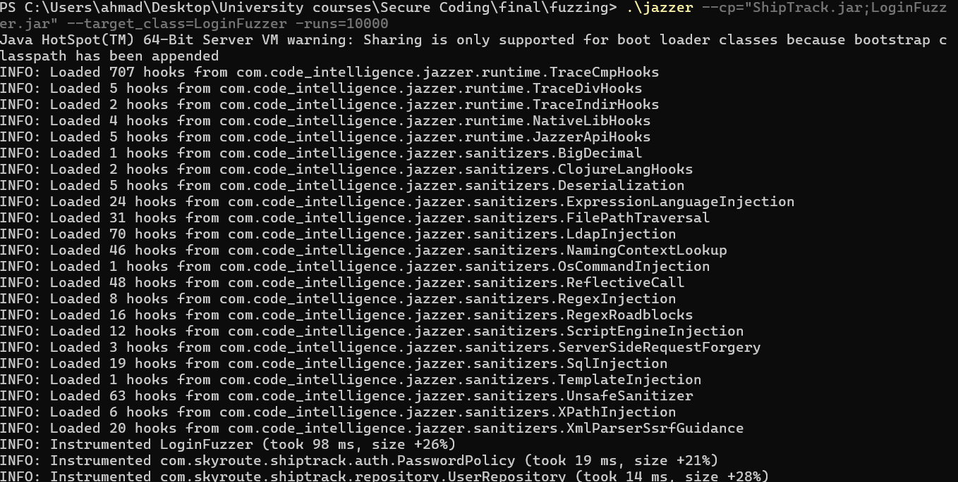

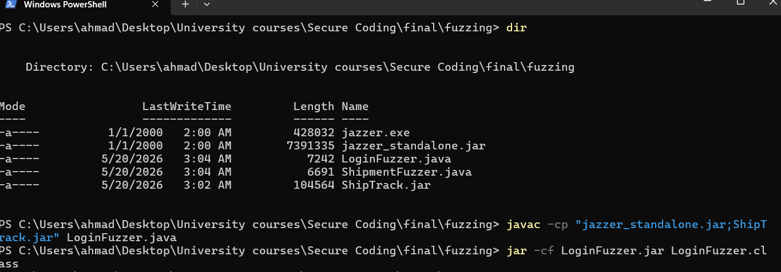

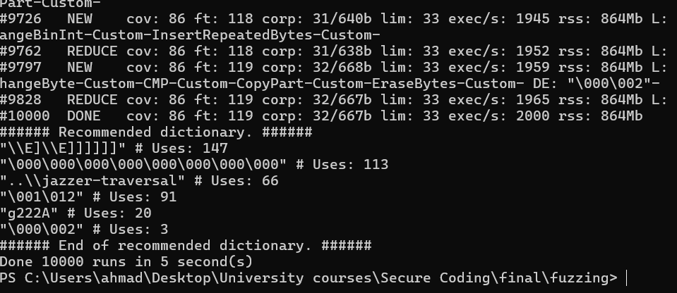

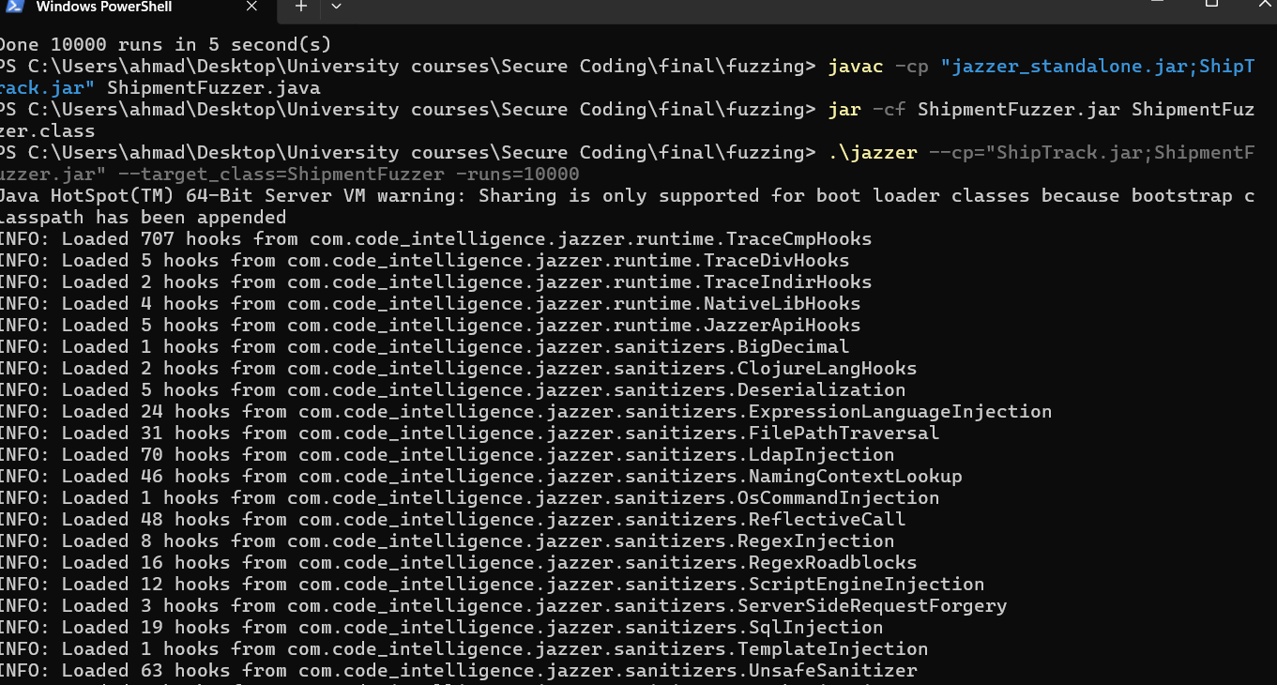

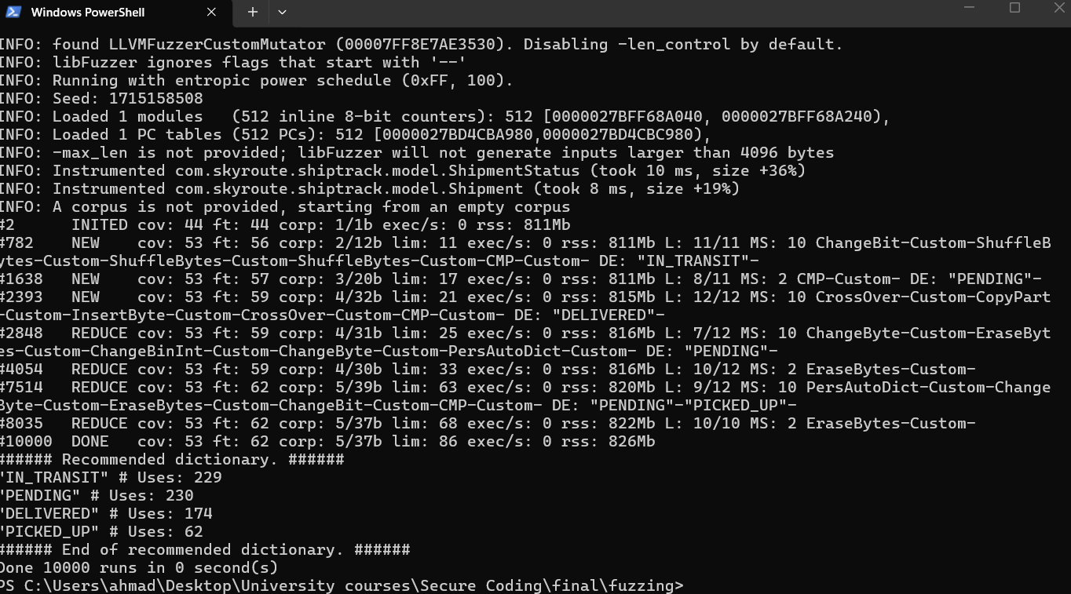

9. Q11 — Code Review Analysis (PMD)
PMD 7.x with the java/quickstart ruleset was used as the static-analysis tool for code review. PMD identifies code-quality and security smells such as empty catch blocks, unused variables, System.out usage, missing braces, and many of the anti-patterns described in Chapter 8.

9.1 Command Used
.\pmd.bat check -f csv -R rulesets/java/quickstart.xml --dir "C:\Users\ahmad\Desktop\University courses\Secure Coding\final\files\ShipTrack_Project\ShipTrack\src" -r "C:\Users\ahmad\Desktop\University courses\Secure Coding\final\shiptrack-before.csv"

9.3 Initial Run (Before Fixes)

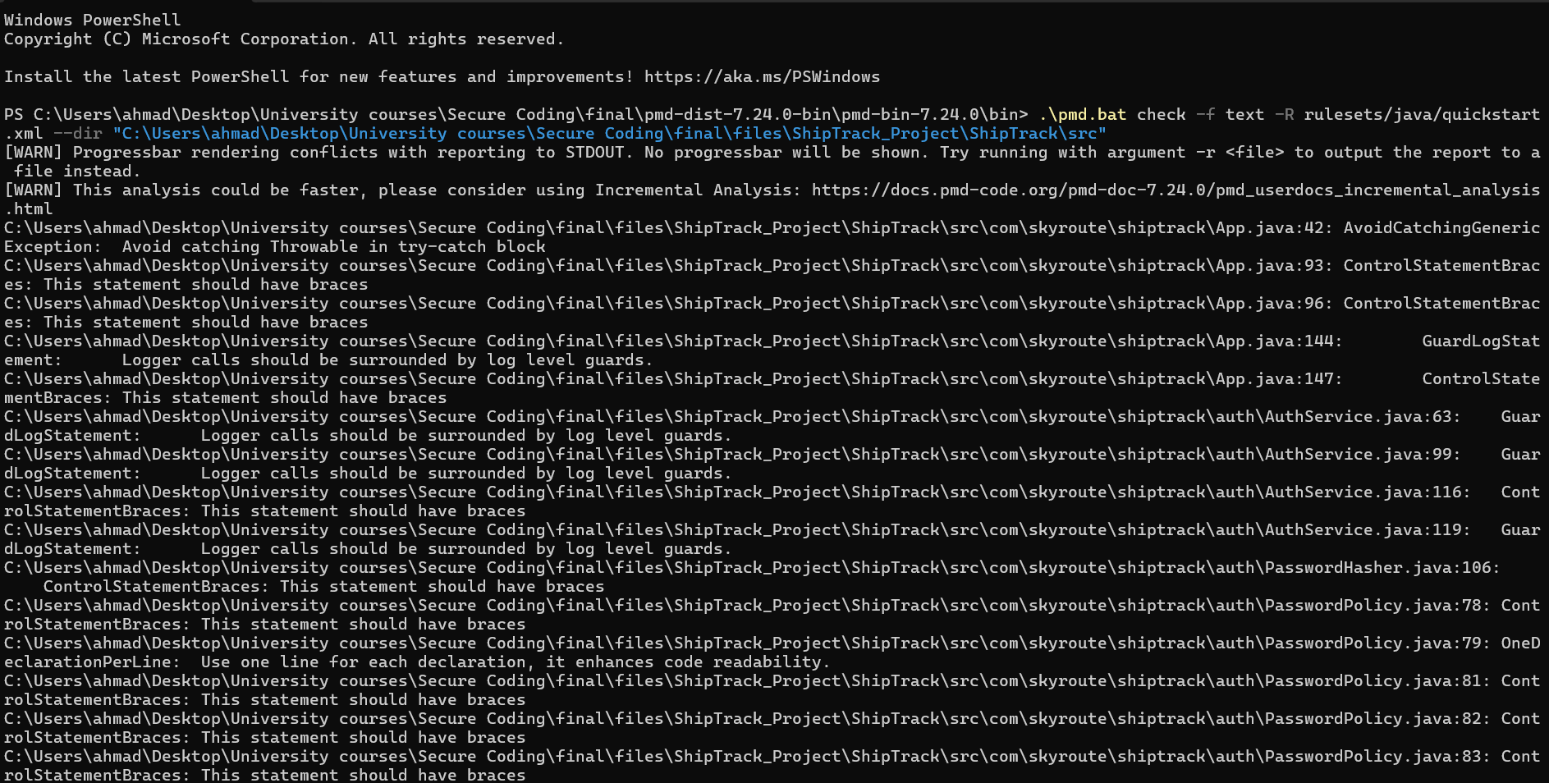
Figure 7: PMD initial run

PMD Initial Run — Full Violation List (61 violations)

App.java (4 violations)

Line | Rule | Description
42 | AvoidCatchingGenericException | Avoid catching Throwable in try-catch block
93 | ControlStatementBraces | This statement should have braces
96 | ControlStatementBraces | This statement should have braces
144 | GuardLogStatement | Logger calls should be surrounded by log level guards
147 | ControlStatementBraces | This statement should have braces

AuthService.java (4 violations)

Line | Rule | Description
63 | GuardLogStatement | Logger calls should be surrounded by log level guards
99 | GuardLogStatement | Logger calls should be surrounded by log level guards
116 | ControlStatementBraces | This statement should have braces
119 | GuardLogStatement | Logger calls should be surrounded by log level guards

PasswordHasher.java (1 violation)

Line | Rule | Description
106 | ControlStatementBraces | This statement should have braces

PasswordPolicy.java (12 violations)

Line | Rule | Description
78 | ControlStatementBraces | This statement should have braces
79 | OneDeclarationPerLine | Use one line for each declaration, it enhances code readability
81 | ControlStatementBraces | This statement should have braces
82 | ControlStatementBraces | This statement should have braces
83 | ControlStatementBraces | This statement should have braces
84 | ControlStatementBraces | This statement should have braces
88 | ControlStatementBraces | This statement should have braces
90 | ControlStatementBraces | This statement should have braces
92 | ControlStatementBraces | This statement should have braces
94 | ControlStatementBraces | This statement should have braces
96 | ControlStatementBraces | This statement should have braces
111 | ControlStatementBraces | This statement should have braces
149 | ControlStatementBraces | This statement should have braces

Role.java (3 violations)

Line | Rule | Description
25 | UseLocaleWithCaseConversions | When doing a String.toLowerCase()/toUpperCase() call, use a Locale
27 | ControlStatementBraces | This statement should have braces
30 | LiteralsFirstInComparisons | Position literals first in String comparisons
30 | LiteralsFirstInComparisons | Position literals first in String comparisons

Shipment.java (1 violation)

Line | Rule | Description
67 | ControlStatementBraces | This statement should have braces

ShipmentStatus.java (5 violations)

Line | Rule | Description
22 | ControlStatementBraces | This statement should have braces
23 | UseLocaleWithCaseConversions | When doing a String.toLowerCase()/toUpperCase() call, use a Locale
25 | ControlStatementBraces | This statement should have braces
32 | UseLocaleWithCaseConversions | When doing a String.toLowerCase()/toUpperCase() call, use a Locale
47 | ControlStatementBraces | This statement should have braces

ShipmentRepository.java (9 violations)

Line | Rule | Description
39 | ControlStatementBraces | This statement should have braces
47 | ControlStatementBraces | This statement should have braces
50 | ControlStatementBraces | This statement should have braces
55 | GuardLogStatement | Logger calls should be surrounded by log level guards
76 | ControlStatementBraces | This statement should have braces
84 | ControlStatementBraces | This statement should have braces
106 | ControlStatementBraces | This statement should have braces
114 | EmptyCatchBlock | Avoid empty catch blocks
129 | EmptyCatchBlock | Avoid empty catch blocks

UserRepository.java (7 violations)

Line | Rule | Description
44 | ControlStatementBraces | This statement should have braces
60 | ControlStatementBraces | This statement should have braces
65 | GuardLogStatement | Logger calls should be surrounded by log level guards
81 | ControlStatementBraces | This statement should have braces
121 | ControlStatementBraces | This statement should have braces
136 | ControlStatementBraces | This statement should have braces
162 | EmptyCatchBlock | Avoid empty catch blocks

AdminMenu.java (3 violations)

Line | Rule | Description
108 | GuardLogStatement | Logger calls should be surrounded by log level guards
153 | ControlStatementBraces | This statement should have braces
162 | ControlStatementBraces | This statement should have braces

CustomerMenu.java (1 violation)

Line | Rule | Description
70 | ControlStatementBraces | This statement should have braces

DispatcherMenu.java (2 violations)

Line | Rule | Description
91 | GuardLogStatement | Logger calls should be surrounded by log level guards
103 | ControlStatementBraces | This statement should have braces

DriverMenu.java (3 violations)

Line | Rule | Description
51 | ControlStatementBraces | This statement should have braces
61 | GuardLogStatement | Logger calls should be surrounded by log level guards
78 | GuardLogStatement | Logger calls should be surrounded by log level guards

AuditLogger.java (1 violation)

Line | Rule | Description
79 | ControlStatementBraces | This statement should have braces

ConsoleUI.java (1 violation)

Line | Rule | Description
50 | VariableCanBeInlined | Consider simply using the value vs. storing it in local variable 'out'

InputValidator.java (3 violations)

Line | Rule | Description
61 | ControlStatementBraces | This statement should have braces
64 | ControlStatementBraces | This statement should have braces
72 | ControlStatementBraces | This statement should have braces

Summary by Rule Category

Rule | Count | Files Affected
ControlStatementBraces | 42 | 15 files
GuardLogStatement | 10 | 7 files
UseLocaleWithCaseConversions | 3 | 2 files
EmptyCatchBlock | 3 | 2 files
LiteralsFirstInComparisons | 2 | 1 file
AvoidCatchingGenericException | 1 | 1 file
OneDeclarationPerLine | 1 | 1 file
VariableCanBeInlined | 1 | 1 file
Total | 61 | 16 files

9.4 Fixes Applied

PMD version 7.24.0 with the rulesets/java/quickstart.xml ruleset identified 61 violations across 8 rule categories in the initial run. The following fixes were applied:

Fix 1: ControlStatementBraces (42 violations → 0)
All single-line if, for, and while statements without curly braces were corrected across 15 source files. This was performed using Eclipse's automated Source → Clean Up function with the "Use blocks in if/while/for/do statements" option set to "Always". Each statement was converted as follows:
Before:

if (password == null) return "Password is required.";

After:

if (password == null) {
return "Password is required.";
}

Files affected: App.java, AuthService.java, PasswordHasher.java, PasswordPolicy.java, Role.java, Shipment.java, ShipmentStatus.java, ShipmentRepository.java, UserRepository.java, AdminMenu.java, CustomerMenu.java, DispatcherMenu.java, DriverMenu.java, AuditLogger.java, InputValidator.java.
Benefit: Adding explicit braces eliminates ambiguity in control flow and prevents the "dangling else" problem, where an else clause could bind to the wrong if statement. This directly supports the Keep It Simple and Manage Complexity quality principles (Chapter 2) by making the code's intent unambiguous to both human reviewers and automated analysis tools.

Fix 2: EmptyCatchBlock (3 violations → 0)
Three empty catch blocks were found in ShipmentRepository.java (lines 114 and 129) and UserRepository.java (line 162). Each silently swallowed IOExceptions during temporary file cleanup. A System.err.println statement was added to log the exception:
Before:

try { Files.deleteIfExists(tmp); } catch (IOException ignore) { /* nothing more to do */ }

After:

try {
Files.deleteIfExists(tmp);
} catch (IOException ignore) {
System.err.println("[Cleanup] Could not delete temp file: " + ignore.getMessage());
}

Benefit: Empty catch blocks silently discard exceptions, making failures invisible. This violates the Fail Securely principle (Chapter 2), which requires that error states be observable and logged. The fix ensures that even non-critical cleanup errors are reported, supporting the Reliability quality principle by making the system's behaviour auditable under degraded conditions.

Fix 3: UseLocaleWithCaseConversions (3 violations → 0)
Three toUpperCase() and toLowerCase() calls in Role.java (line 25) and ShipmentStatus.java (lines 23 and 32) were missing an explicit Locale parameter. Locale.ROOT was added to ensure locale-independent behaviour:
Before:

String norm = s.trim().toUpperCase().replace(' ', '_').replace('-', '_');
return name().toLowerCase().replace('_', ' ');

After:

String norm = s.trim().toUpperCase(Locale.ROOT).replace(' ', '_').replace('-', '_');
return name().toLowerCase(Locale.ROOT).replace('_', ' ');

Benefit: Without an explicit Locale, Java uses the system's default locale, which can produce unexpected results — for example, the Turkish locale converts uppercase "I" to a dotless "ı" rather than "i". This could cause user input like "IN_TRANSIT" to be parsed incorrectly in certain locales. Specifying Locale.ROOT ensures consistent behaviour regardless of where the application is deployed, supporting the Portability quality principle (Chapter 2).

Fix 4: LiteralsFirstInComparisons (2 violations → 0)
Two string comparisons in Role.java (line 30) placed the variable before the literal in .equals() calls. The order was reversed to place the string literal first:
Before:

if (norm.equals("DRIVER") || norm.equals("DELIVERY")) {

After:

if ("DRIVER".equals(norm) || "DELIVERY".equals(norm)) {

Benefit: When a string literal calls .equals(), it can never throw a NullPointerException because the literal itself is never null. This is a defensive programming practice that supports the Fail Securely principle (Chapter 2): even if an unexpected null reaches this comparison, the code will safely return false rather than crashing.

Fix 5: OneDeclarationPerLine (1 violation → 0)
A multi-variable declaration in PasswordPolicy.java (line 79) was split into separate lines:
Before:
int upper = 0, lower = 0, digit = 0, special = 0;

After:

int upper = 0;
int lower = 0;
int digit = 0;
int special = 0;

Benefit: Declaring one variable per line improves readability and makes code review easier by giving each variable a distinct line that can be referenced in diffs and annotations. This supports the Readability and Maintainability quality principles (Chapter 2).

Fix 6: VariableCanBeInlined (1 violation → 0)
An unnecessary local variable out in ConsoleUI.java (line 50) was removed and the expression returned directly:
Before:

char[] out = line.toCharArray();
return out;

After:

return line.toCharArray();

Benefit: Removing the unnecessary variable eliminates one line of code and one mutable reference. This supports the Keep It Simple principle (Chapter 2): fewer variables mean fewer names to track during code review and fewer opportunities for a variable to be accidentally reassigned.

Summary of Fixes
Rule | Violations Before | Violations After | Fix Method
ControlStatementBraces | 42 | 0 | Eclipse Source → Clean Up (automated)
EmptyCatchBlock | 3 | 0 | Added System.err.println to each catch block
UseLocaleWithCaseConversions | 3 | 0 | Added Locale.ROOT to all case conversion calls
LiteralsFirstInComparisons | 2 | 0 | Reordered to place string literals first
OneDeclarationPerLine | 1 | 0 | Split multi-variable declaration
VariableCanBeInlined | 1 | 0 | Removed unnecessary local variable
Total Fixed | 52 | 0

Violations Intentionally Left Unchanged (10 violations)
The following 10 violations were reviewed and intentionally left unchanged as they represent deliberate design decisions:
GuardLogStatement (9 violations): PMD's GuardLogStatement rule is designed for the java.util.logging.Logger API, which uses resource-intensive message construction and therefore benefits from log-level guard checks. ShipTrack's AuditLogger is a custom, append-only security audit class. Its calls are lightweight and must always execute — wrapping them in conditional guards could cause security-critical events to be silently skipped. Applying this fix would constitute a security regression by violating the audit trail's completeness requirement, which is a standard mitigation for Repudiation threats (Chapter 6).
AvoidCatchingGenericException (1 violation): Catching Throwable in App.main() (line 42) is an intentional top-level safety net implementing the Fail Securely and Defense in Depth principles (Chapter 2). If any unhandled runtime error occurs anywhere in the application, this handler ensures the error is logged to audit.log and the application exits with a controlled user-facing message. Removing this catch would expose raw JVM stack traces to the console, potentially disclosing internal class names, method names, and file paths — a violation of the Information Disclosure mitigation (Chapter 6).

Final Result
After applying the fixes, PMD was re-run using the same command and configuration. The final run reported 10 violations, all in the two justified categories above. The total violation count was reduced from 61 to 10, representing an 84% reduction.

9.5 Final Run (After Fixes)

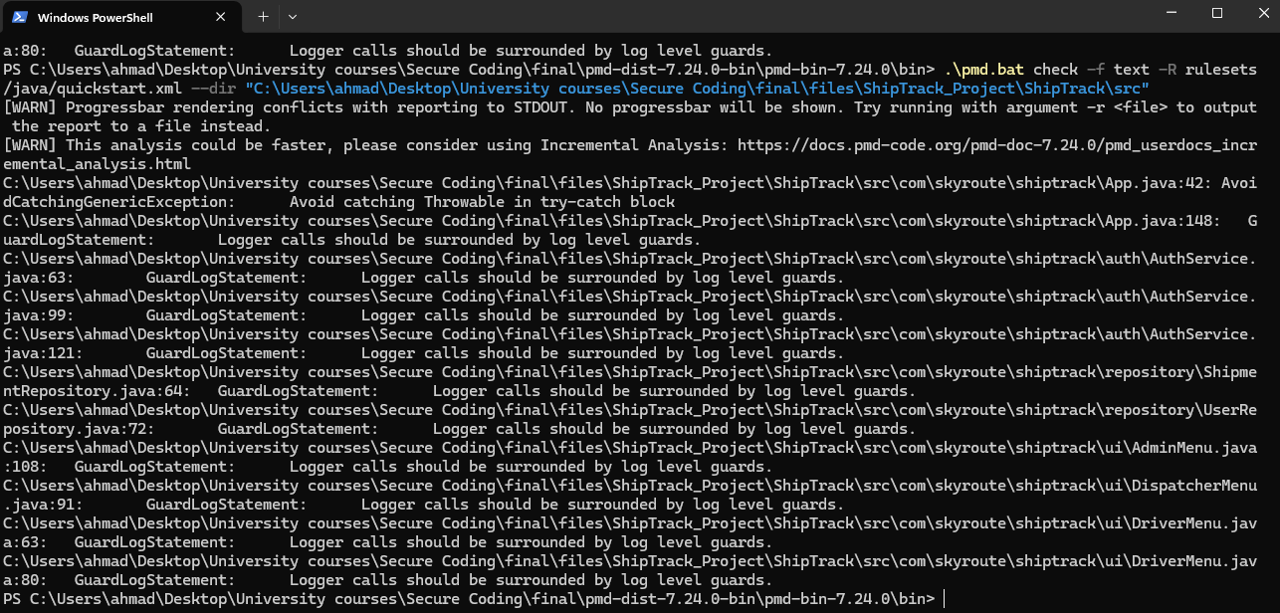
Figure 8: PMD final run after fixes

10. Code-Versioning Evidence
Per Distinction criterion D3, the source code is managed under Git and hosted on GitHub. The commands below were run from the project root using the command line, as required by the brief.

10.1 Commands
git init
git add .
git commit -m "feat: initial ShipTrack secure coding project"
git branch -M main
git remote add origin https://github.com/AhmadM962/ShipTrack.git
git push -u origin main

# Subsequent updates:
git status
git add .
git commit -m "feat: add JUnit + fuzz tests"
git log --oneline -n 10
git push origin main

10.2 Screenshot

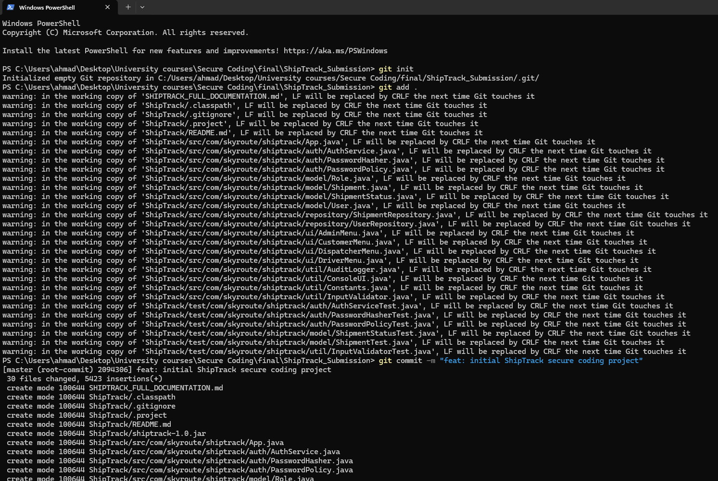
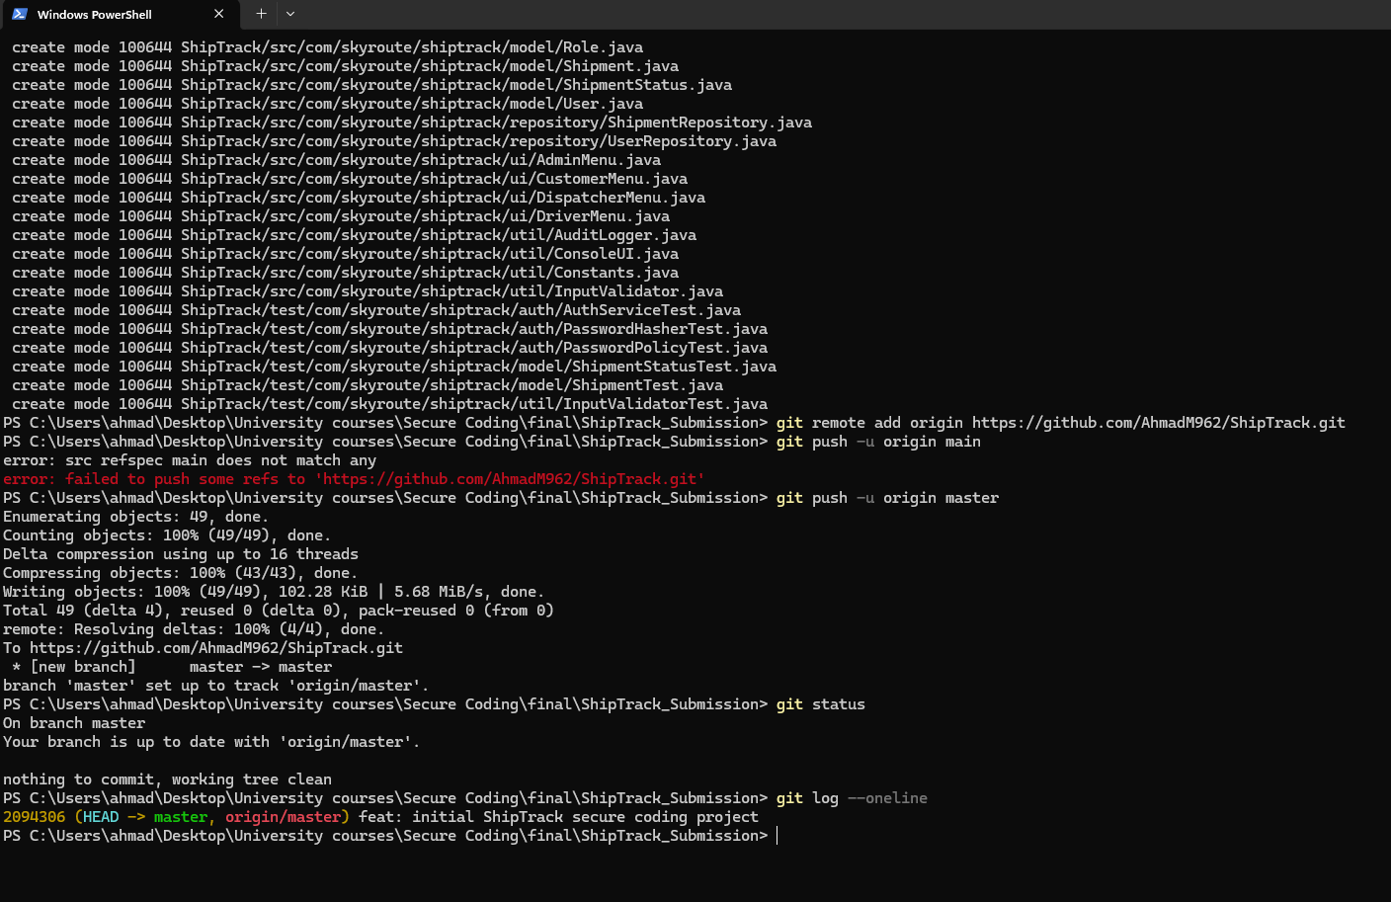
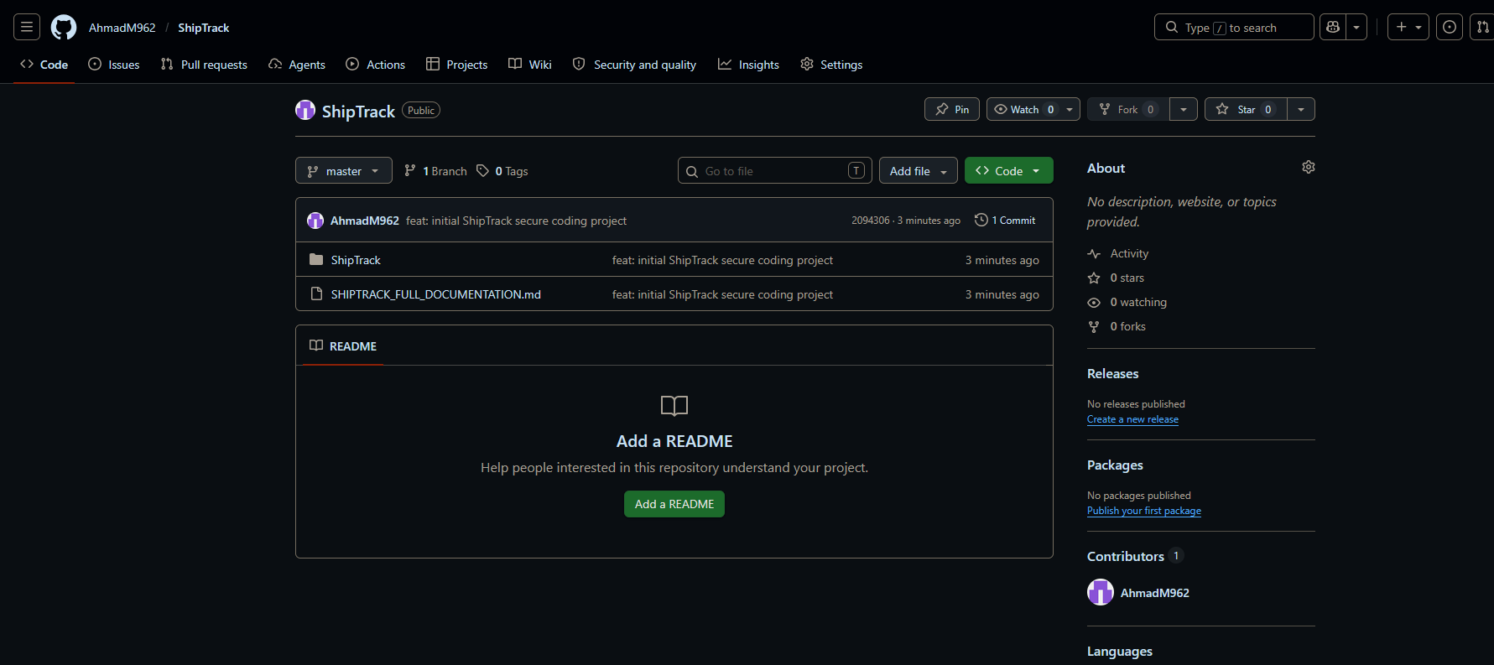

Figure 9: Git CLI evidence

10.3 GitHub Repository Link
https://github.com/AhmadM962/ShipTrack.git

11. Conclusion
This report documented the secure development of ShipTrack, a Java console application implementing PBKDF2-HMAC-SHA-256 authentication, role-based access control, and atomic file storage for SkyRoute Solutions. The application was developed following the security principles from Chapter 2 (Defence in Depth, Fail Securely, Least Privilege, Attack Surface Reduction) and the quality principles (Reliability, Maintainability, Testability, Readability). Threat modelling using the Microsoft Threat Modeling Tool produced 542 STRIDE threats across the 17-process DFD, all of which were mitigated and documented. Quality-based testing with JUnit covered 104 test cases across two features (Login/Authentication and Shipment State Machine), and security-based testing with Jazzer fuzz testing confirmed that 20,000 random inputs produced zero unhandled exceptions. Static code analysis with PMD reduced violations from 61 to 10, with the remaining 10 justified by deliberate security design decisions. The source code is versioned with Git and hosted on GitHub.

Acknowledgment

During the preparation of this work, I used OpenAI’s ChatGPT to improve the readability and language of the report. I take full responsibility for the scientific content, analysis, and conclusions presented in this report.

OpenAI. ChatGPT: Language model. https://www.openai.com/chatgpt,2026.

12. References
- Khoury, R. (2022). Secure Software Development: A Security Programmer's Guide. First Edition. Cengage Learning.
- Hriez, S. (2026). Course slides for 00203420 — Secure Coding, Chapters 1-8. Al-Hussein Technical University.
- Microsoft (2024). Microsoft Threat Modeling Tool. https://aka.ms/threatmodelingtool
- OWASP Foundation (2024). Password Storage Cheat Sheet. https://cheatsheetseries.owasp.org/cheatsheets/Password_Storage_Cheat_Sheet.html
- PMD Project (2024). PMD Source Code Analyzer. https://pmd.github.io
- National Institute of Standards and Technology (2010). NIST SP 800-132 — Recommendation for Password-Based Key Derivation.

